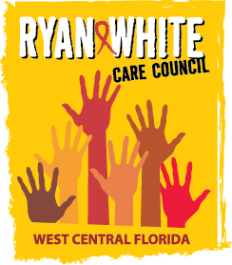
WEST CENTRAL FLORIDA RYAN WHITE CARE COUNCIL
STANDARDS, ISSUES, AND OPERATIONS COMMITTEE (SIOC)
GOTO WEBINAR
FRIDAY, OCTOBER 30, 2020
9:30AM – 11:00 AM

AGENDA

- Call to Order Myles

- Roll Call and Introductions Finn

- Resource Prioritization and Recommendations Committee Konnerth
  - Part A Reallocation Recommendations
- Planning and Evaluation Committee Gutierrez
  - 2020-2021 Service Priorities
- Membership Committee Freeman-Foster
  - Membership Renewal

- Membership and Recruitment Discussion Members
- Committee Membership Members
- NMAC Training Members
- Adjournment Myles

The next Care Council meeting will be held on Wednesday, November 4, 2020. The location is TBA.

