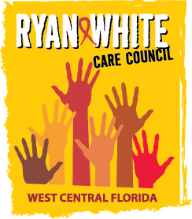
WEST CENTRAL FLORIDA RYAN WHITE CARE COUNCIL
COMMUNITY ADVISORY COMMITTEE
GOTOWEBINAR
THURSDAY, JANUARY 28, 2020
1:00 P.M. - 2:30 P.M.

AGENDA
- Call to Order Chair

- Roll Call Staff

- Changes to Agenda Members

- Adoption of Minutes Chair
October 22, 2020 (Attachment)

- Care Council Report Co-Chair

- Moment of Inspiration Members
- 2020-2021 Committee Work Plan Members

- Client/Community Input Members

- Announcements Members/Guests

- Adjournment Chair

Note: Items in bold are action items.

The next meeting of the Ryan White Care Council will be Wednesday, February 3, 2021 from 1:30 pm to 3:30 pm on GoTo Webinar.
The CARE COUNCIL website is operating at www.thecarecouncil.org. Agendas and minutes will be posted on this website.

