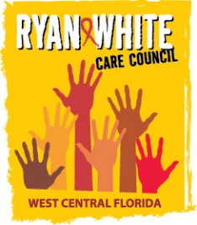
WEST CENTRAL FLORIDA RYAN WHITE CARE COUNCIL
VIRTUAL GOTOWEBINAR
WEDNESDAY, JANUARY 6, 2021
1:30 P.M. – 3:30 P.M.

AGENDA
I. Call to Order Finn

II. Roll Call and Introductions Myles

III. Changes to Agenda Finn

IV. Moment of Silence Myles

V. Review of November 4, 2020 Minutes Finn

VI. Chairperson’s/Vice Chairperson’s Report Finn

VII. Recipient’s Report Arnold

VIII. Lead Agency Report Everhart/Lightsey

IX. Care Council Planning Staff Report Ardjomand-Kermani/Scussel

X. Committee Reports

- Resource Prioritization & Allocation Recommendations (RPARC) Konnerth
  - Part B Expenditure Report (Attachment)

XI. Public Policy Report/Community Input Members/Guests

XII. Prevention Activities/Quality Management Members/Guests

XIII. Announcements Members/Guests

XIV. Adjournment Finn

Note: Items in bold require action. Care Council meetings are audio recorded.

The next Care Council meeting will be held on February 3, 2021 from 1:30pm- 3:30pm, location to be determined.

The CARE COUNCIL website is operating at www.thecarecouncil.org.
Agendas and minutes will be posted on this website.

