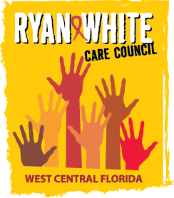
WEST CENTRAL FLORIDA RYAN WHITE CARE COUNCIL
WOMEN, INFANTS, CHILDREN, YOUTH AND FAMILIES COMMITTEE
GOTOWEBINAR
THURSDAY, JANUARY 28, 2021
10:00 AM – 11:30 AM

AGENDA

- Call to Order Chair

- Roll Call Staff

- Changes to Agenda Members

- Adoption of Minutes Chair
October 22, 2020 (Attachment)

- Care Council Report Co-Chair

- Moment of Inspiration Members

- Women/Youth Concerns/Updates Members

- Community and Client Concerns/Announcements Members/Guests

- Adjournment Chair

Note: Items in bold are action items.
The next meeting of the Ryan White Care Council will be on February 3, 2021 from 1:30 pm to 3:30 pm. The location is TBD.
The CARE COUNCIL website is operating at www.thecarecouncil.org. Agendas and minutes will be posted on this website.

