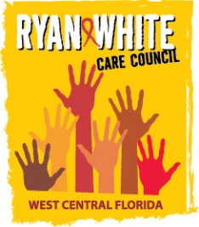
WEST CENTRAL FLORIDA RYAN WHITE CARE COUNCIL
VIRTUAL GOTOWEBINAR
WEDNESDAY, FEBRUARY 3, 2021
1:30 P.M. – 3:30 P.M.

AGENDA
I. Call to Order Finn

II. Roll Call and Introductions Myles

III. Changes to Agenda Finn
Discussion regarding in-person meetings added prior to public policy

IV. Moment of Silence Myles

V. Adoption of Minutes: Finn
- November 4, 2020 Minutes (Attachment)
- January 6, 2021 Minutes (Attachment) Finn

VI. Chairperson’s/Vice Chairperson’s Report Finn

VII. Recipient’s Report Arnold

VIII. Lead Agency Report Everhart/Lightsey

IX. Care Council Planning Staff Report Ardjomand-Kermani/Scussel

X. Committee Reports
- Standards, Issues, Operations Committee (SIOC) Myles
- Community Advisory Committee (CAC) Scussel
- Health Services Advisory (HSAC) Rugg
- Membership Freeman-Foster
- Planning and Evaluation (P&E) Gutierrez
- Resource Prioritization & Allocation Recommendations (RPARC) Konnerth
  - Assessment of the Administrative Mechanism (AAM) Cavalleri
- Women, Infants, Children, Youth & Families (WICY&F) Delgado

XI. Ending the HIV Epidemic Update
- Hillsborough County Recipient
- Pinellas County Lead Agency

Addition to agenda: discussion regarding in-person meetings

XII. Public Policy Report/Community Input Members/Guests
Add Housing item to agenda
XIII. Prevention Activities/Quality Management Members/Guests

XIV. Announcements Members/Guests

XV. Adjournment Finn

Note: Items in bold require action. Care Council meetings are audio recorded.

The next Care Council meeting will be held on March 3, 2021 from 1:30pm- 3:30pm, via GoToWebinar.

The CARE COUNCIL website is operating at www.thecarecouncil.org.
Agendas and minutes will be posted on this website.

