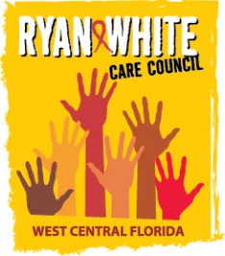
WEST CENTRAL FLORIDA RYAN WHITE CARE COUNCIL
VIRTUAL GOTOWEBINAR
WEDNESDAY, MARCH 3, 2021
1:30 P.M. – 3:30 P.M.

AGENDA
I. Call to Order Finn

II. Roll Call and Introductions Myles

III. Changes to Agenda Finn

IV. Moment of Silence Myles

V. Adoption of minutes tabled until April 2021 in-person Care Council meeting Finn

VI. Chairperson’s/Vice Chairperson’s Report Finn

VII. Recipient’s Report Arnold

VIII. Lead Agency Report Everhart/Lightsey

IX. Care Council Planning Staff Report Ardjomand-Kermani/Scussel

X. Housing Opportunities for People with HIV/AIDS (HOPWA) Report Henderson

XI. Committee Reports
- Standards, Issues, Operations Committee (SIOC) Myles
- Community Advisory Committee (CAC) Scussel
- Health Services Advisory (HSAC) Rugg
- Membership, Nominations, Recruitment & Training Committee Freeman-Foster
- Planning and Evaluation (P&E) Gutierrez
- Resource Prioritization & Allocation Recommendations (RPARC) Bruton
- Women, Infants, Children, Youth & Families (WICY&F) Delgado

XII. Ending the HIV Epidemic Update
- Hillsborough County Arnold
- Pinellas County Everhart/Lightsey

XIII. Public Policy Report/Community Input Members/Guests

XIV. Prevention Activities/Quality Management Members/Guests

XV. Announcements Members/Guests

XVI. Adjournment Finn

Note: Items in bold require action. Care Council meetings are audio recorded.

The next Care Council meeting will be held on April 7, 2021 from 1:30pm- 3:30pm, at Metro Inclusive Health’s Saint Petersburg Office, located at 3251 3rd Ave N, St. Petersburg, FL 33713

The CARE COUNCIL website is operating at www.thecarecouncil.org.
Agendas and minutes will be posted on this website.

