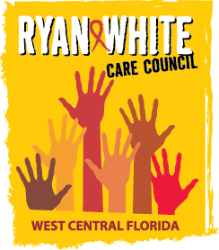
WEST CENTRAL FLORIDA RYAN WHITE CARE COUNCIL
HEALTH SERVICES ADVISORY COMMITTEE
GOTOWEBINAR
THURSDAY, FEBRUARY 18, 2021
1:30 PM – 3:00 PM

AGENDA

- Call to Order Co-Chair

- Roll Call and Introductions Staff/Members

- Changes to Agenda Members

- Adoption of Minutes
Minutes deferred to next in-person meeting

- Care Council Report Ardjomand-Kermani
- Review Impact of ADAP & ACA Members

- Announcements/Community Concerns Members

- Adjournment Co-Chair

Note: Items in bold require action by the membership.

The Ryan White Care Council’s next meeting will be March 3, 2021 from 1:30pm to 3:30pm, via GoToWebinar

The CARE COUNCIL website is at www.thecarecouncil.org.
Meeting information, agendas and minutes will be posted on this website.

