WEST CENTRAL FLORIDA RYAN WHITE CARE COUNCIL
HEALTH SERVICES ADVISORY COMMITTEE
VIRTUAL GOTOWEBINAR
THURSDAY, DECEMBER 17, 2020
1:30 P.M. – 3:00 P.M.

MINUTES

CALL TO ORDER | The meeting was called to order by Elizabeth Rugg, Chair at 1:30 P.M.
ATTENDANCE | Members Present: Elizabeth Rugg, Terry Law, Michelle Keyes, Elizabeth Rugg, Peggy Wallace, Amanda Miller  Members Absent: Kim Molnar  Guests Present: None.  Recipient Staff Present: None  Lead Agency Staff Present: Yashika Everhart  Health Council Staff Present: Lisa Nugent, Katie Scussel, Naomi Ardjomand-Kermani
CHANGES TO AGENDA | None
ADOPTION OF MINUTES | All minutes are tabled until in-person meetings reconvene in 2021.
CARE COUNCIL REPORT | Care Council did not meet in December 2020 and will reconvene in January 2021. Planning Council staff will be meeting with Part A staff for technical assistance in transitioning to a hybrid virtual/in-person meeting model.
REVIEW OF THE 2019 CARE CONTINUUM | Planning Council Support staff, Naomi Ardjomand-Kermani, reviewed the adopted 2019 Care Continuum with committee members, specifically noting that the terminology of MSM (men who have sex with men) has now been changed to MMSC (male-to-male sexual contact). They began with continuum data for the entire Eligible Metropolitan Area (EMA):  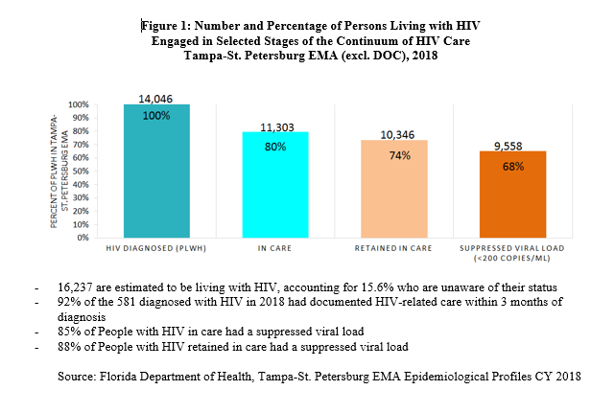  Ardjomand-Kermani continued by focusing on the following three priority populations:  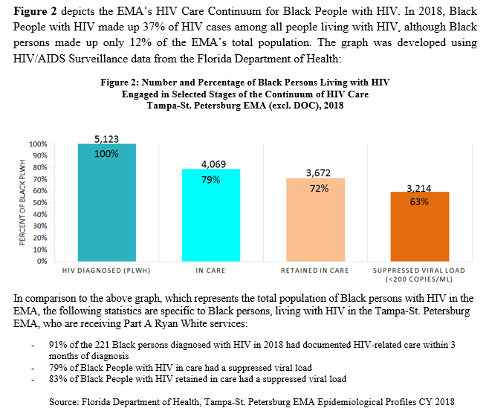  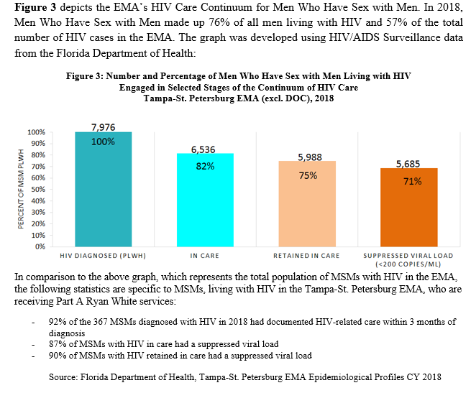  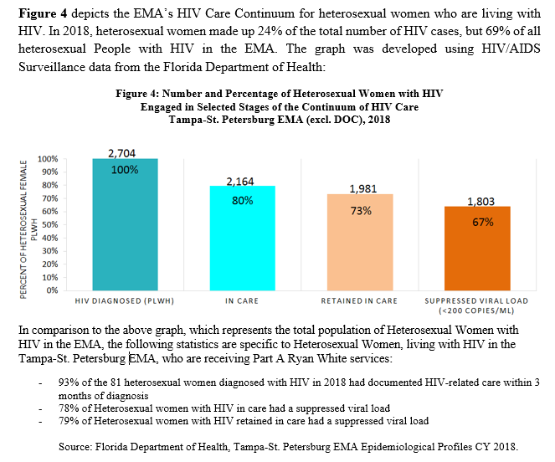  Ardjomand-Kermani concluded noting that the area’s suppressed viral load is higher than the national average.
REVIEW OF IMPACT OF ADAP & ACA | Committee member, Michelle Keyes, noted that experiences at Metro Inclusive Health, with open enrollment, has been a smooth and simple process. AIDS Drug Assistance Program (ADAP) appointments are being pushed back to focus on ADAP Premium Plus clients at this time. Chair, Elizabeth Rugg, asked if Insurance Services Provider would be necessary to assist and Keyes replied with no expected need at this time.
ANNOUNCEMENTS/  COMMUNITY CONCERNS | The committee will meet again on February 18, 2021, location to be determined.
ADJOURNMENT | There being no further business to come before the Committee, the meeting was adjourned at 1:50 p.m.

