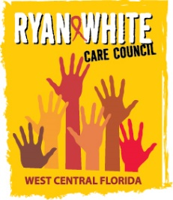
WEST CENTRAL FLORIDA RYAN WHITE CARE COUNCIL
PLANNING & EVALUATION COMMITTEE
GOTOWEBINAR
THURSDAY, FEBRUARY 11, 2021
9:30 AM TO 11:00 AM

AGENDA

I. Call to Order Chair

II. Roll Call Staff

III. Review of Minutes Chair
  - October 8, 2020 (Attachment)
  - December 10, 2020 (Attachment)

IV. In-person Quorum Discussion Members

V. Community Concerns & Announcements Members

VI. Adjournment Chair

Note: Items in bold are action items.

The Ryan White Care Council’s next meeting will be March 3, 2021 from 1:30pm to 3:30pm, location yet to be determined.

The CARE COUNCIL website is at www.thecarecouncil.org.
Agendas and minutes will be posted on this website.

