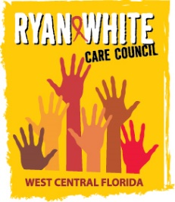
WEST CENTRAL FLORIDA RYAN WHITE CARE COUNCIL
PLANNING & EVALUATION COMMITTEE
EPIC SUNCOAST HOSPICE GARDEN HOUSE
THURSDAY, MARCH 11, 2021
9:30 AM TO 11:00 AM

AGENDA

I. Call to Order Chair

II. Roll Call Staff

III. Changes to Agenda Members

IV. Review of Minutes Chair
  - October 8, 2020 (Attachment)
  - December 10, 2020 (Attachment)
  - February 11, 2021 (Attachment)

V. Care Council Report Co-Chair

VI. 2020 Care Continuum (Attachment) Staff

VII. 2020-2021 Epidemiology Report (Attachment) Staff

VIII. Community Concerns & Announcements Members

IX. Adjournment Chair

Note: Items in bold are action items.

The Ryan White Care Council’s next meeting will be April 7, 2021 from 1:30pm to 3:30pm, at Metro Inclusive Health Saint Petersburg Office
located at 3251 3rd Ave N, St. Petersburg, FL 33713.

The CARE COUNCIL website is at www.thecarecouncil.org.
Agendas and minutes will be posted on this website.

