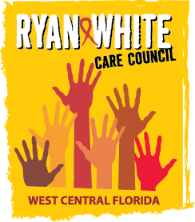
WEST CENTRAL FLORIDA RYAN WHITE CARE COUNCIL
METRO INCLUSIVE HEALTH – SAINT PETERSBURG OFFICE
WEDNESDAY, APRIL 7, 2021
1:30 P.M. – 3:30 P.M.

MINUTES

CALL TO ORDER | The meeting of the Ryan White Care Council was called to order by Nolan Finn, Chair, at 1:46 p.m.
ROLL CALL AND INTRODUCTIONS | See attached attendance list.
CHANGES TO AGENDA | Post meeting PCS staff note: due to the restriction of time Ending the HIV Epidemic (EHE) updates, Public Policy/Community Input, Prevention Activities/Quality Management, and Announcements were struck from the agenda. Both Recipient and Lead Agency noted that their respective EHE updates were shared during their agency reports. Chair, Nolan Finn, offered an opportunity for timely announcements to be made, but no attendees did so.
MOMENT OF SILENCE | Vice-Chair, Edward Myles, asked members to take a moment to give honor and recognition to those that we have lost to HIV, those struggling with HIV, and those who are currently unaware of their serostatus.
ADOPTION OF MINUTES | The minutes for October 7, 2020 (Attachment) were approved by acclamation (M: Devine, S: Molnar).  The minutes for November 4, 2020 (Attachment) were approved by acclamation (M: Devine, S: Delgado).  The minutes for January 6, 2021 (Attachment) were approved by acclamation (M: Devine, S: Conder).  The minutes for February 3, 2021 (Attachment) were approved by acclamation (M: Devine, S: Molnar).  The minutes for March 3, 2021 (Attachment) were approved by acclamation (M: Bruton, S: Devine).
CHAIR/VICE CHAIR’S REPORT | Vice-Chair, Myles (Edward) Myles, announced that EVOLVE Tampa Bay will be hosting an event on April 17, 2021 with Metro Inclusive Health.  Care Council Chair, Nolan Finn, reminded the Council that the Florida Comprehensive Planning Network (FCPN) is seeking an alternative for his position of patient care coordinator. Finn asks that anyone interested get in touch with him for more information. He noted that participation in the FCPN involves learning best practices and will be held by phone or virtually. Finn ended his report by announcing that April is National Volunteer month and thanked all members of the Care Council for their time and service.
RECIPIENT’S REPORT | Recipient, Aubrey Arnold, began his report by expressing his gratitude for everyone attending the Council meeting in-person and virtually. He noted that many groups’ business has been hindered even by meeting virtually and that we are doing wonderfully with connecting to those who are not attending meetings in-person. Arnold continued that much progress has been made on our part, all things considered. Vaccines are rolling out and there is a lot of hope to be had.  Arnold went on to report that the Eligible Metropolitan Area (EMA) received the Part A award for the new funding year (FY) 2021-2022, in the amount of $10,353,255 which is not much less than last year. However, because pharmacy (local) funding has been underutilized, the EMA is looking at decreasing this service’s budget overall by half a million dollars. He emphasized that no services will be harmed or hindered in doing so. The EMA has received their final scoring criteria for the current Part A award, with no findings or weaknesses cited, for a 96% final score. He noted that he is puzzled when looking at all pieces, that cuts occurred within the Minority AIDS Initiative (MAI) in supplemental funding. All other funding is flat, as is historically the case, and all contracts are in place for this year. Part A is in the process of closing the FY 2020 grant, prepping final numbers, and financial reports for the Health Resources and Services Administration (HRSA). The EMA has spent out over 98% of the total grant award, despite all issues faced due to the pandemic. Care Council Chair, Nolan Finn, added that he plans to inquire about the EMA’s 96% score on the next monthly call with the EMA’s Project Officer.  Member, Lisa Conder, asked if the overall funding decreased and Arnold assured Conder that funding is historically flat funded He went on to note that 66% of the overall funding allocation is based on a formula of actual cases of HIV, as per what is reported to the Centers for Disease Control (CDC), and 33% is supplemental and competitive, which is why the grant application process occurs annually. The disconnect is why the application score did not equate to additional funding.  As additional information, Arnold shared that the full grant award for Ending the HIV Epidemic Initiative (EHE) FY 2021-2022 was received for a total $1,667,000. Of this funding $667,000 is additional (60% to Hillsborough County and 40% to Pinellas County) and Part A will be working with partnerships in Pinellas and Hillsborough Counties for allocation recommendations. The hope to add supportive housing and mental health services in both counties, ramp up Early Intervention Services (EIS), and boost mental health services. A procurement opportunity will be announced within the coming month. A virtual site visit, with HRAS in January, went well and were commended on the work that the EHE is doing in Hillsborough and Pinellas Counties. Arnold has been asked to share their successes, via a quarterly EHE webinar, on March 17, 2021. No significant findings or corrective action was required; however, 4 recommendations were made.  A webinar is planned for the end of April 2021 to review new e2Hillsborough enhancements, Arnold is excited for FY 21, as they will be working with many different agencies to lessen the burden of paper records and sharing data. They will allow agencies to get rid of all paper files if all goes as planned.
LEAD AGENCY REPORT | Lead Agency staff, Yashika Everhart, acknowledged that all but one Part B contract has been executed and a final expenditure report will be provided at the next Resource Prioritization & Allocation Recommendations (RPARC) Committee meeting. Everhart has no AIDS Drug Assistance Program (ADAP) updates other than to remind members that open enrollment is still underway.  Lead Agency staff, Darius Lightsey, continued the report to share that Pinellas County’s EHE initiative is still in year 1 of 5 of the funding periods, which runs from August to July each year. All unexpended funds will be rolled to year 2. They are amid the internal budget process for the Department of Health (DOH), settling on the upcoming Part B budget as well as EHE’s budget. The next quarterly EHE Advisory Council meeting will be held virtually on April 29, 2021 – registration information will be shared soon. He ended his report with the announcement that Abundant Life Ministries and Banyan Tree will be hosting an event on April 10, 2021 from 11:00am – 2:00pm. Speakers, games and entertainment will be provided.
CARE COUNCIL PLANNING STAFF REPORT | Planning Council Support staff, Naomi Ardjomand-Kermani, announced that the upcoming Planning and Evaluation (P&E) and RPARC meetings will be held in-person with the option to call-in. They reiterated the importance of making in-person quorum for all committees with actionable business on the agenda; this includes meeting in-person quorum at the May 2021 Care Council meeting.
HOUSING OPPORTUNITIES FOR PEOPLE WITH HIV/AIDS (HOPWA) REPORT | HOPWA Representative, Kayon Henderson, began the HOPWA report mentioning that they have an additional $800,000 for HIV housing. Their grant with DOH has been a challenge as the two-year grant agreement for 2 years was received, but the 2019-2020 reimbursements have yet to arrive. Henderson expressed concern over the need to provide more housing relief to individuals in need, but with no timeline for reimbursement in place. She noted that services in 2020 were not 100% reimbursed as DOH felt that HOPWA didn’t do enough to advertise the available funding. It is because of this that HOPWA is skeptical about taking additional funding to bridge gaps if they are not certain that they will be reimbursed to sustain programming. Hillsborough County hopes to find more housing to offer, but contracts keep increasing prices once they know that the City of Tampa is willing to pay. They are currently looking for housing in Ybor’s industrial district to house 100-300 people at once.  Henderson continued and noted a slight increase in HOPWA funds, with three-year agreement in place. They do not expect to advertise procurement for new services for another 3 years unless additional funding is received. They are currently using administration funds to have applications for the city and county processed and have been successfully hitting the mark of processing approximately 1,000 applications per week. They are currently focused on those who are 50% below the Federal Poverty Line (FPL) and will be moving on to those 80% below the FPL.  Care Council member, J. Carl Devine, asked why it’s so difficult for smaller organizations to receive HOPWA funding and Henderson replied that they advertised and requested smaller organizations sit on procurement committees. She went on that HOPWA must consider the families and cannot rely on an agency to continue to receive funding and avoid disrupting services, thus they execute 3-year contracts. Henderson continued that all size agencies are encouraged to apply – they are more concerned with providing housing in all 4 counties they serve and not the size of the agency providing services. Care Council Chair, Nolan Finn, added that smaller agencies should be encouraged to apply, and Devine responded with frustration over the lack of advertisement of the request for applications (RFA). Henderson reminded the Council that she announced the open procurement at Care Council frequently and Nolan Finn sat on the review board. She added that Metro Inclusive Health is a newly funded provider this year.  Devine respectfully reminded the Council that he has been trying to access emergency housing funding for Pinellas County and was repeatedly told that funding would only be granted to those already funded. Recipient, Aubrey Arnold, announced that there will be an opportunity to apply for housing funding soon and will be sure to notify Council members by e-mail, social media, newspaper, and by word of mouth. He added that there is a notification list anyone can be put on. Lead Agency staff, Darius Lightsey, noted that Part B would be happy to help promote these funding opportunities to ensure that the most vulnerable populations receive this information. Devine then asked how many minority-owned agencies are funded by HOPWA and Henderson explained that only 501(c)(3) non-profits are eligible, thus applying agencies cannot be owned.
COMMITTEE REPORTS | - Standards, Issues, and Operations Committee (SIOC) – Myles (Edward) Myles, Care Council Vice-Chair  SIOC did not meet in March 2021.  - Community Advisory Committee (CAC) – Katie Scussel, Planning Council Support Staff  CAC met on March 25, 2021 at 1:30 p.m. by way of GoToWebinar, but no one showed up. Scussel reminded the Council that this is the second month in a row that no one as attended the committee meeting. Care Council Chair, Nolan Finn, added his concern about the function of the CAC and what it is missing.  CAC will meet again April 21, 2021 at 1:30 p.m. by way of GoToWebinar.  C. Health Services Advisory Committee (HSAC) – Elizabeth Rugg, Chair  HSAC did not meet in March 2021. HSAC will meet next on April 15, 2021 at 1:30 p.m., by way of GoToWebinar.  D. Membership, Nominations, Recruitment & Training Committee – Tonicia Freeman-Foster, Chair  Membership did not meet March 2021 but will reconvene on April 19, 2021 by way of GoToWebinar.  Finn asked if discussions about lowering the quorum number for the Council and committees should be discussed. He went on to commit to talking to Membership to find constructive and creative ways to meet in-person quorum.  Arnold offered to discuss lowering the threshold for in-person quorum with the County attorney. He hopes that the County attorney will be able to attend an upcoming Care Council meeting to answer any questions and receive further guidance.  E. Planning & Evaluation Committee (P&E) – Naomi Ardjomand-Kermani, Planning Council Support Staff  P&E met March 11, 2021 at 9:30 a.m. at EPIC’s Suncoast Hospice location in the Garden House.  - Tampa – Saint Petersburg Eligible Metropolitan Area (EMA) 2020 HIV Care Continuum Report  Background  The Tampa-St. Petersburg Eligible Metropolitan Area (EMA), located on the west central coast of Florida, is comprised of Hernando, Hillsborough, Pasco, and Pinellas Counties. The following graphs depict the population-based continuum of care for the EMA, specifically identifying number of persons diagnosed with HIV; number of persons in care; number of persons retained in care; and number of persons with a suppressed viral load. The three subsequent graphs depict disparities among the viral suppression rates for three of the most disproportionately impacted minority populations in the EMA: all Black persons living with HIV; cisgender men living with HIV who engage in male-to-male sexual contact (MMSC), and all heterosexual cisgender women living with HIV. These graphs were developed using HIV/AIDS Surveillance data from the Florida Department of Health.  Planning Council Support (PCS) staff, Naomi Ardjomand-Kermani, presented the 2020 Care Continuum for the Tampa-St. Petersburg Eligible Metropolitan Area (EMA) (Figure 1), located on the west central coast of Florida, is comprised of Hernando, Hillsborough, Pasco, and Pinellas Counties. This population-based continuum of care for the EMA, specifically identifies the number of persons diagnosed* with HIV; number of persons in care**; number of persons retained in care***; and number of persons with a suppressed viral load****.  Figure 1: Number and Percentage of PWH  Engaged in Selected Stages of the Continuum of HIV Care  Tampa-St. Petersburg EMA (excl. DOC*)  - 15,834 are estimated to be living with HIV, accounting for 13.5% who are unaware of their status  - 92% of the 537 diagnosed with HIV in 2019 had documented HIV-related care within 3 months of diagnosis  - 87% of People with HIV in care had a suppressed viral load  - 90% of People with HIV retained in care had a suppressed viral load  * Department of Corrections  Source: Florida Department of Health, Tampa-St. Petersburg EMA Epidemiological Profiles CY 2019  *HIV Diagnosed = Include persons whose HIV diagnosis occurred during the period specified, data as of 6/30/2020.  **In Care = People with HIV (PWH) with at least one documented viral load (VL) or cluster of differentiation 4 (CD4) lab, medical visit, or prescription from 1/1/2019 through 3/31/2020, data as of 6/30/2020.  ***Retained in Care = PWH with two or more documented VL or CD4 labs, medical visits, or prescriptions at least three months apart from 1/1/2019 through 6/30/2020, data as of 6/30/2020.  ****Viral Load Suppression = PWH with a suppressed VL (<200 copies/mL) on the last VL from 1/1/2019 through 3/31/2020, data as of 6/30/2020.  The 2020 Care Continuum also depicts disparities among viral suppression rates for three of the most disproportionately impacted minority populations in the EMA: all Black persons living with HIV; cisgender men living with HIV who engage in male-to-male sexual contact (MMSC), and all heterosexual cisgender women living with HIV.  The poverty rate among many Black populations is high. The socioeconomic issues associated with poverty, such as lack of access to high-quality health care, safe and stable housing, and inclusive, comprehensive, and culturally appropriate HIV prevention education all increase Black populations’ vulnerability to HIV and comorbid health risk. The graph was developed using HIV/AIDS Surveillance data from the Florida Department of Health. Figure 2 depicts the EMA’s HIV Care Continuum for Black People with HIV. In 2019, Black People with HIV made up 37% of HIV cases among all People with HIV, although Black persons made up only 12% of the EMA’s total population. This disparity reflects the marginalized social status of Black populations in the United States, which is further exaggerated by the stigmatization of HIV, identifying as a gender or sexual minority-based discrimination, medical mistrust, and the fear of mistreatment. As shown in Figure 2, viral suppression rates among these populations, within the Tampa-St. Petersburg EMA, are low overall (68%), but increases 18% if the Person with HIV is retained in HIV-related care.  Figure 2: Number and Percentage of Black PWH  Engaged in Selected Stages of the Continuum of HIV Care  Tampa-St. Petersburg EMA (excl. DOC)  - 90% of the 208 Black persons diagnosed with HIV in 2019 had documented HIV-related care within 3 months of diagnosis  - 79% of Black People with HIV in care had a suppressed viral load  - 86% of Black People with HIV retained in care had a suppressed viral load  Source: Florida Department of Health, Tampa-St. Petersburg EMA Epidemiological Profiles CY 2019  Socioeconomic barriers such as homophobia, stigma, and lack of access to quality health care especially affect Black cisgender men who engage in male-to-male sexual contact (MMSC).  These barriers to care, combined with a fear of discrimination and a lack of accessible, comprehensive, and inclusive safer sex education, may prevent cisgender men who engage in MMSC of all races/ethnicities from seeking HIV testing and treatment. As a result, cisgender men who engage in MMSC are more vulnerable to HIV. Figure 3 depicts the EMA’s HIV Care Continuum for cisgender male-to-male sexual contact (MMSC). In 2019, MMSC made up 75% of all cisgender men living with HIV and 57% of the total number of HIV cases in the EMA. The graph was developed using HIV/AIDS Surveillance data from the Florida Department of Health. As is seen in Figure 3, 92% of PWH who engage in MMSC were virally suppressed when retained in care, as compared to viral suppression among the overall population of PWH who engage in MMSC (77%), within in the EMA.  Figure 3: Number and Percentage of PWH Who Engage in Cisgender MMSC  Engaged in Selected Stages of the Continuum of HIV Care  Tampa-St. Petersburg EMA (excl. DOC)  - 93% of the 335 PWH who engage in MMSC diagnosed with HIV in 2019 had documented HIV-related care within 3 months of diagnosis  - 77% of PWH who engage in MMSC in care had a suppressed viral load  - 92% of PWH who engage in MMSC retained in care had a suppressed viral load  Source: Florida Department of Health, Tampa-St. Petersburg EMA Epidemiological Profiles CY 2019.  In general, receptive sex is the most common mode of HIV transmission among all genders, thus those who engage in MMSC and cisgender women who engage in heterosexual receptive anal and/or vaginal sex are among those most vulnerable to HIV. Some cisgender women, including those in monogamous partnerships, may not be aware of their partners’ sexual and injection drug use behaviors and forgo safer sex practices, such as the use of condoms/barriers, pre-exposure prophylaxis (PrEP), or HIV testing.  Cisgender women who have experienced sexual assault/trauma, and lack familial and/or social support, may also be more likely to engage in survival sex work, increasing their vulnerability to contracting HIV, especially if they are unable access PrEP and/or unable to negotiate condom use with their sexual partners.  Figure 4 depicts the EMA’s HIV Care Continuum for cisgender heterosexual women with HIV. In 2019, heterosexual women made up 19% of the total number of HIV cases, but 68% of all heterosexual People with HIV in the EMA. Once again, as seen in Figure 4, viral suppression is far likelier when PWH are retained in care and this is no different among cisgender heterosexual women. An additional barrier to retention in care is a lack of accessible and affordable childcare. Nationally, cisgender women with HIV are twice as likely (76%) as cisgender men with HIV (34%) to be caring for at least one child under the age of 18. The graph was developed using HIV/AIDS Surveillance data from the Florida Department of Health.  Figure 4: Number and Percentage of Cisgender Heterosexual Women with HIV  Engaged in Selected Stages of the Continuum of HIV Care  Tampa-St. Petersburg EMA (excl. DOC)  - 93% of the 72 Cisgender heterosexual women diagnosed with HIV in 2019 had documented HIV-related care within 3 months of diagnosis  - 73% of Cisgender heterosexual women with HIV in care had a suppressed viral load  - 89% of Cisgender heterosexual women with HIV retained in care had a suppressed viral load  Source: Florida Department of Health, Tampa-St. Petersburg EMA Epidemiological Profiles CY 2019.  Action Required  THAT THE CARE COUNCIL ADOPT THE 2020 CARE CONTINUUM REPORT FOR THE TAMPA – SAINT PETERSBURG ELIGIBLE METROPOLITAN AREA (EMA).  This was approved by acclamation (S: Devine).  - Tampa – Saint Petersburg EMA 2020 – 2021 Epidemiology Report  Background  The 2020-2021 Epidemiology Report examines the following demographic characteristics: gender, ethnicity, county of residence, mode of transmission and age at diagnosis. Information is broken out by geographic area including Total Service Area (TSA), Eligible Metropolitan Area (EMA) and non-EMA counties. Incidence data is provided to assess the increases and decreases in the epidemic.  Planning Council Support (PCS) staff, Naomi Ardjomand-Kermani, presented the 2020-2021 Epidemiology Report which examines the demographic characteristics such as: gender, ethnicity, county of residence, mode of transmission and age at diagnosis. Information was broken out by geographic area including Total Service Area (TSA), Eligible Metropolitan Area (EMA) and non-EMA counties. Incidence data was provided to assess the increases and decreases in the epidemic.  According to the Florida Department of Health’s Epidemiological Profile, new HIV cases (incidence) in the EMA rose 3.5% from 2017 to 2018 but decreased overall by 1.1% from 2017 to 2019. New cases of AIDS decreased 11.2% from 2017 to 2019. The most common mode of transmission for HIV in the EMA was cisgender (those who agree with their designation at birth) male-to-male sexual contact (MMSC), followed by cisgender male-to-female heterosexual contact, and persons who inject drugs (PWID) among all genders. Changes in the incidence and prevalence for HIV and AIDS, from 2017 to 2019, are shown in Figure 1.  Figure 1: Tampa/St. Petersburg EMA Epidemiological Profile  CY 2017 CY 2018 CY 2019  Incidence Prevalence Incidence Prevalence Incidence Prevalence  HIV 543 6,361 562 6,467 537 6,591  AIDS 285 7,409 263 7,354 253 7,360  TOTAL 828 13,770 825 13,821 790 13,951  Source: Florida Department of Health, Tampa-St. Petersburg EMA Epidemiological Profiles CY 2017, 2018, 2019  The incidence of HIV among cisgender men in the EMA increased from 431 cases in 2017 to 445 cases in 2019: a 3.2% increase. During the same time frame, new HIV cases among cisgender women decreased by 16.5% from 109 to 91. The incidence of cisgender male AIDS cases decreased 14%, from 222 to 191 cases. The incidence of cisgender female AIDS cases increased 1.6% from 61 to 62 cases.  HIV incidence is shown in Figure 2. Over the past three years there has been a slight increase in the incidence of HIV in the EMA among White and Latinx populations. From 2017-2019, HIV incidence increased 4.5% for Latinx persons and 6.5% for White persons, while new cases of HIV decreased 10.3% among Black persons.  Source: Florida Department of Health, Tampa-St. Petersburg EMA Epidemiological Profiles CY 2017, 2018, 2019.  AIDS incidence is shown in Figure 3. There has been a decrease in the incidence of AIDS among Black, White, and Latinx populations, with the most significant decrease among Latinx persons. From 2017-2019, the incidence of AIDS decreased by 6.3% for White persons, 11% for Black persons, and 25% for Latinx persons. The “other” race category is the combined number of cases among Asian, American Indian/Alaska Native (Indigenous), Native Hawaiian/Pacific Islander, and those who identify as multi-race. This racial category experienced a 33% increase in new AIDS cases; however, contextually this was an increase from 6 to 8 cases over the three-year period.  Source: Florida Department of Health, Tampa-St. Petersburg EMA Epidemiological Profiles CY 2017, 2018, 2019.  The 2019 calendar year saw minor demographic changes in HIV and AIDS prevalence. White persons in the EMA represented two-thirds of the population and 42% of all HIV cases. Black persons accounted for 37% and Latinx persons represented 19% of all HIV cases. White persons represented the largest prevalence of AIDS cases in the EMA with 44%, followed by Black persons with 36%, and Latinx persons with 17%. Black persons were disproportionately impacted by HIV/AIDS representing 37% of HIV cases and 36% of the AIDS cases, although only 12% of the EMA’s total population was Black.  THE EPIDEMIC BY TOTAL SERVICE AREA  The State of Florida is comprised of numbered areas. The West Central Florida Ryan White Care Council covers three areas: Area 5, Area 6, and Area 14. The data is not available by county, only by area or EMA. To provide information regarding all the areas covered by the Care Council and not just the EMA, Figures 4 – 9 represent the three geographic areas that make up the Total Service Area (TSA).  AREA 5: PASCO & PINELLAS COUNTIES  Figure 4: HIV by Year of Diagnosis in Area 5  by County of Residence at Diagnosis, 2017-2019  County HIV Incidence 2017 2018 2019 2018-2019 % Change  Pasco 40 52 46 -12%  Pinellas 178 180 196 9%  Source: Florida Department of Health, HIV/AIDS Section, 2019.  Figure 5: AIDS by Year of Diagnosis in Area 5  by County of Residence at Diagnosis, 2017-2019  County AIDS Incidence 2017 2018 2019 2018-2019 % Change  Pasco 28 22 21 -5%  Pinellas 93 85 88 4%  Source: Florida Department of Health, HIV/AIDS Section, 2019.  AREA 6: HERNANDO, HILLSBOROUGH, & MANATEE COUNTIES  Figure 6: HIV by Year of Diagnosis in Area 6  by County of Residence at Diagnosis, 2017-2019  County HIV Incidence 2017 2018 2019 2018-2019 % Change  Hernando 18 17 10 -41%  Hillsborough 307 313 285 -9%  Manatee 46 44 37 -16%  Source: Florida Department of Health, HIV/AIDS Section, 2019.  Figure 7: AIDS by Year of Diagnosis in Area 6  by County of Residence at Diagnosis, 2017-2019  County AIDS Incidence 2017 2018 2019 2018-2019 % Change  Hernando 11 13 5 -62%  Hillsborough 153 143 139 -3%  Manatee 26 21 17 -19%  Source: Florida Department of Health, HIV/AIDS Section, 2019.  AREA 14: HARDEE, HIGHLANDS, & POLK COUNTIES  Figure 8: HIV by Year of Diagnosis in Area 14  by County of Residence at Diagnosis, 2017-2019  County HIV Incidence 2017 2018 2019 2018-2019 % Change  Hardee 1 2 0 -100%  Highlands 5 6 13 117%  Polk 97 110 129 17%  Source: Florida Department of Health, HIV/AIDS Section, 2019.  Figure 9: AIDS by Year of Diagnosis in Area 14  by County of Residence at Diagnosis, 2017-2019  County AIDS Incidence 2017 2018 2019 2018-2019 % Change  Hardee 0 2 1 -50%  Highlands 6 4 8 100%  Polk 45 45 56 24%  Source: Florida Department of Health, HIV/AIDS Section, 2019.  Action Required  THAT THE CARE COUNCIL ADOPT THE 2020-2021 EPIDEMIOLOGY REPORT FOR THE TAMPA – SAINT PETERSBURG ELIGIBLE METROPOLITAN AREA (EMA). This was approved by acclamation (S: Devine).  P&E will meet again on May 13, 2021 at 9:30 a.m. at EPIC’s Suncoast Hospice location in the Garden House.  F. Resource Prioritization & Allocation Recommendations (RPARC) – Lillie Bruton, Co-Chair  Committee Co-Chair, Lillie Bruton, reported that RPARC met on March 11, 2021 at 11:00 a.m. at EPIC’s Suncoast Hospice Clearwater Garden House. Quorum was met (in-person) with 6 in-person and 1 virtual member, 2 guests, and 6 staff members present.  - Part A Expenditure Report  Bruton began reviewing the report with a preface that the expenditures reviewed at that time are quite different from the actual expenditures as Part A is almost spent-out at this time. No attendees asked questions about the report.  RPARC will meet again on May 13, 2021 at 11:00 a.m. at EPIC’s Suncoast Hospice Clearwater Garden House.  G. Women, Infants, Children, Youth, & Families (WICY&F) – Paula Delgado, Co-Chair  WICY&F met on March 25, 2021 at 10:30 a.m. by way of GoToWebinar. The Committee met quorum with 7 members and 1 staff present.  Members discussed how the Children’s AIDS Foundation helped 15 families with donations from an anonymous donor.  WICY&F will reconvene on April 22, 2021 at 10:00 a.m. via GoToWebinar.
IDEA (INFECTIOUS DISEASE ELIMINATION ACT) EXCHANGE TAMPA PRESENTATION | Bernice K. McCoy, MPH, Associate Director of Social Medicine Programs in the Division of Emergency Medicine at Tampa General Hospital presented IDEA to Care Council members to share their plans for Tampa. McCoy shared the following brochure for distribution among members of the Care Council:  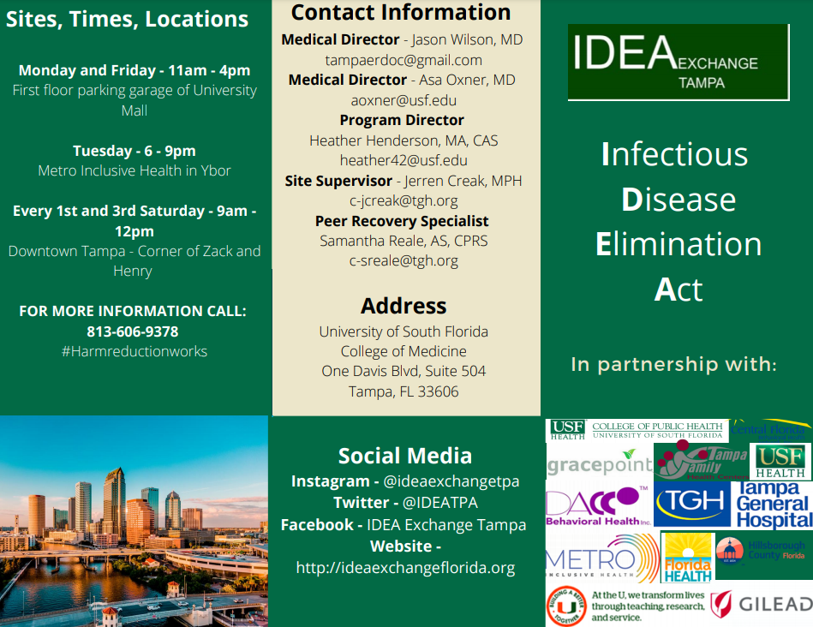  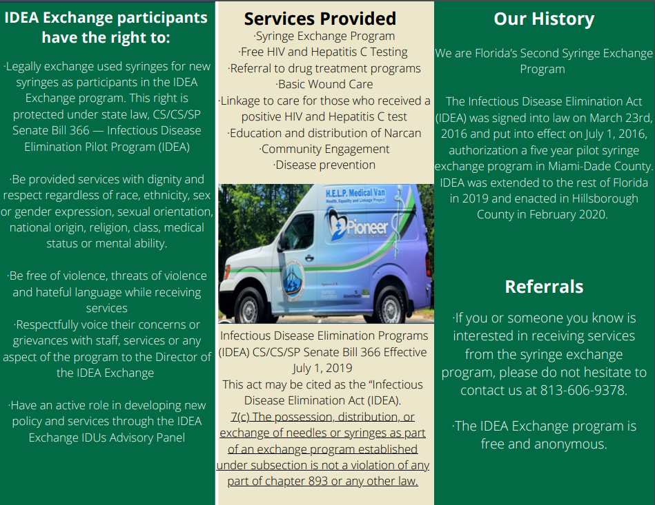
ADJOURNMENT | There being no further business to come before the Care Council, the meeting was adjourned at approximately 3:53 p.m.  PCS Staff Note: Members were welcomed to leave at 3:30 p.m. if they needed to do so as the meeting ran over time.
Note: A recording of the meeting is available for review at the Suncoast Health Council. | For further details about this Care Council meeting, please visit thecarecouncil.org to access meeting minutes and handouts.
SUNSHINE LAW | REMEMBER: Florida's SUNSHINE LAW requires that meetings are noticed and open to the public, and that minutes are taken at each meeting. For the Care Council, this means that meetings are advertised in advance and members of the public are welcome to attend and participate in public comment. Notes are taken to make sure a record of the meeting is made so anyone can read what action was taken.  The SUNSHINE LAW does not allow members of the same council or committee to talk to each other outside of a publicly noticed meeting about matters that might come before the Council for a vote. For the Care Council, this means that every member of the Council must decide how to vote on their own and must make sure not to discuss upcoming agenda items or other council matters with other council members.
LIST OF HANDOUTS | - April 7, 2021 Agenda  - April 2021 Calendar  - October 7, 2020 minutes (Attachment)  - November 4, 2020 minutes (Attachment)  - January 6, 2021 minutes (Attachment)  - February 3, 2021 minutes (Attachment)  - March 3, 2021 minutes (Attachment)  - Background: 2020 Care Continuum (Attachment  - 2020 Care Continuum (Attachment)  - Background: 2020-2021 Epidemiology Report (Attachment)  - 2020-2021 Epidemiology Report (Attachment)  - Part A Expenditure Report (Attachment)

ATTENDANCE LIST: APRIL 7, 2021

Care Council Members | Attendance
Nolan Finn (Chair) | X in-person
(Myles) Edward Myles (Vice-Chair) | X in-person
Joel Carrier
Lisa Conder | X in-person
Paula Delgado | X in-person
J Carl Devine | X in-person
Kayon Henderson | X in-person
Vincent Kaborycha
Kamaria Laffrey
Jeffrey Lluberes | ALT in-person
Michelle McKinney | X
Amanda Miller | X
Kimberly Molnar | X in-person
Peggy Wallace | ALT in-person
Charles Ware
Associate Members | Attendance
Nicole Kish
Recipient Staff | Attendance
Aubrey Arnold | X in-person
Dorinda Seth
Maria Teresa Jaureguizar
Lead Agency Staff | Attendance
Darius Lightsey | X in-person
Yashika Everhart | X
Health Council Staff | Attendance
Lisa Nugent | X
Katie Scussel | X in-person
Naomi Ardjomand-Kermani | X in-person
Regular Guests | Attendance
Jim Roth
Dave Konnerth
Elizabeth Rugg | X
Emily Hughart
David Cavalleri | X
Tonicia Freeman-Foster | X
Kirsty Gutierrez | X
Allison Rapp
Lillie Bruton | X in-person
Crystal Waddy
Angela Kellogg | X
Michelle Keyes | X
Sam Quintero | X
Donna Sabatino
Antonio Miles | X
Guests | Attendance
Michael Alonso | X
Jasmine Alvarado
Katherine Barbera
Conrad Barzarea
Shakayla Birch
Dawn Branley
Taryn Buckley
Jose Camino
Joshua Cardwell
Michael Carlton
Mike Catala
Gregory Clark
Everis Clarke
Donna Corpuz
Anne Cronyn | X
Diamond Cunningham
Scott Dartange
Michael Dunn
Darlene Duran
Lolita Emanuel-Brown
Brittany Frederick
Karlie Gallagher
Geneva Galloway
Beth Gotti
Tashann Grant
Pierre Guttenberg
Khalil Hall
Indica Harris
Chris Holland
Lovell Harp
Shayla Hobbs
Michael Holder
Sherri Hoover
Nicole Houston
Karen Hoyle
Marylin Jones
Vicki Kenyon
Janet Kitchen
Topher Larkin
Grace Levy-Clarke
Andrew Maldonado
Olinda Manjenje
Andrew McFarbme
Sean McIntosh
Mark Mischan
Carmen Millie Montanez
Lauren Miller
Jamie Morano
Denise Mote | X
Michael Neuges | X
Sheyla Nobles
James Ogedegbe
Vicky Oliver
Sebastian Osorio
Steve Palermo
Terrell Parker
Guttenberg Pierre
Juliana Pinero
Dee Prendergast
Hope Sharon Proell
Ashley Quidaciolu
Dedra Richardson
Shaquira Robinson
Allison Ruby
Sheila Ruck
Christine Santos
Michelle Scavnicky
Dartange Scott
Garrett Sears
Ashley Smith
Ashley Snug
Diego Villalba
Chris Walker | X
Bernard Washington | X
Ronald Weston
ALT= Alternate present EX = Excused

I, Chair Nolan Finn, do certify that these minutes have been approved by me and the members of the Care Council on this day, May 5, 2021.

Nolan Finn, Chair: ________________________________________________

Scharff DP, Mathews KJ, Jackson P, Hoffsuemmer J, Martin E, Edwards D. More than Tuskegee: understanding mistrust about research participation. J Health Care Poor Underserved. 2010;21(3):879-897. doi:10.1353/hpu.0.0323
Matthews DD, Herrick AL, Coulter RW, et al. Running Backwards: Consequences of Current HIV Incidence Rates for the Next Generation of Black MSM in the United States. AIDS Behav. 2016;20(1):7-16. doi:10.1007/s10461-015-1158-z
Cavanaugh CE, Hansen NB, Sullivan TP. HIV sexual risk behavior among low-income women experiencing intimate partner violence: the role of posttraumatic stress disorder. AIDS Behav. 2010;14(2):318-327. doi:10.1007/s10461-009-9623-1
Marshall BD, Shannon K, Kerr T, Zhang R, Wood E. Survival sex work and increased HIV risk among sexual minority street-involved youth. J Acquir Immune Defic Syndr. 2010;53(5):661-664. doi:10.1097/QAI.0b013e3181c300d7
Schuster MA, Kanouse DE, Morton SC, et al. HIV-infected parents and their children in the United States. Am J Public Health. 2000;90(7):1074-1081. doi:10.2105/ajph.90.7.1074

