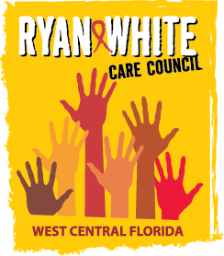
WEST CENTRAL FLORIDA RYAN WHITE CARE COUNCIL
HEALTH SERVICES ADVISORY COMMITTEE
GOTOWEBINAR
THURSDAY, APRIL 15, 2021
1:30 PM – 3:00 PM

AGENDA

- Call to Order Chair

- Roll Call and Introductions Staff/Members

- Changes to Agenda Members
- Care Council Report Co-Chair
- Review Impact of ADAP & ACA Members

- Announcements/Community Concerns Members
    - Committee Purpose Planning Discussion

- Adjournment Chair

Note: Items in bold require action by the membership.

The Ryan White Care Council’s next meeting will be May 5, 2021 from 1:30pm to 3:30pm, at Metro Inclusive Health’s Saint Petersburg Office - 3251 3rd Ave N, St. Petersburg, FL 33713

Please adhere to social distancing protocol and always wear a mask.

The CARE COUNCIL website is at www.thecarecouncil.org.
Meeting information, agendas and minutes will be posted on this website.

