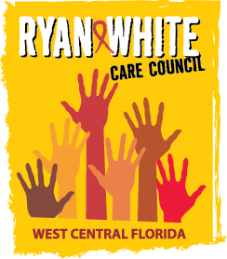
WEST CENTRAL FLORIDA RYAN WHITE CARE COUNCIL
HEALTH SERVICES ADVISORY COMMITTEE
GOTOMEETING
THURSDAY, JUNE 17, 2021
1:30 PM – 3:00 PM

AGENDA

- Call to Order Chair

- Roll Call and Introductions Staff/Members

- Changes to Agenda Members

- Review of Minutes Members

  - April 15, 2021 (Attachment)

- Care Council Report Rugg/Molnar

- Mental Health Services & Expansion of RW System of Care Members

  - CVS Mental Health Article (Attachment)
  - CVS Offering In-Store Mental Health Counseling in Tampa Area (Attachment)
- Review Impact of ADAP & ACA Members

- Announcements/Community Concerns Members

- Adjournment Chair

Note: Items in bold require action by the membership.

The Ryan White Care Council’s next meeting is August 4, 2021 from 1:30pm to 3:30pm, at Metro Inclusive Health – Saint Petersburg Office.

PLEASE REMEMBER: Florida's SUNSHINE LAW requires that meetings are noticed and open to the public, and that minutes are taken at each meeting. For the Care Council, this means that meetings are advertised in advance and members of the public are welcome to attend and participate in public comment. Notes are taken to make sure a record of the meeting is made so anyone can read what action was taken.

The SUNSHINE LAW does not allow members of the same council or committee to talk to each other outside of a publicly noticed meeting about matters that might come before the Council for a vote. For the Care Council, this means that every member of the Council must decide how to vote on their own and must make sure not to discuss upcoming agenda items or other council matters with other council members.

The CARE COUNCIL website is at www.thecarecouncil.org.
Meeting information, agendas and minutes will be posted on this website.

