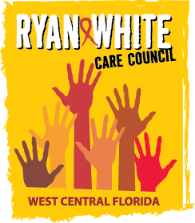
WEST CENTRAL FLORIDA RYAN WHITE CARE COUNCIL
RESOURCE PRIORITIZATION AND ALLOCATION RECOMMENDATIONS
EPIC SUNCOAST HOSPICE – GARDEN HOUSE
THURSDAY, APRIL 8, 2021
11:00 A.M. - 12:30 P.M.

AGENDA

- Call to Order Chair

- Roll Call Staff

- Changes to Agenda Members

IV. Adoption of Minutes Chair
- March 11, 2021 (Attachment)

V. Care Council Report Co-Chair

VI. Recipient Update Arnold
- Allocation Proposals

VII. Lead Agency Update Everhart

VIII. Community Input/Announcements Members

IX. Adjournment Chair

Note: Items in bold are action items.

The Ryan White Care Council’s next meeting will be May 5, 2021 from 1:30pm to 3:30pm, at Metro Inclusive Health Saint Petersburg Office.

The CARE COUNCIL website is at www.thecarecouncil.org.
Meeting information, agendas and minutes will be posted on this website.

