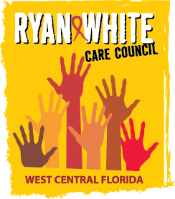
WEST CENTRAL FLORIDA RYAN WHITE CARE COUNCIL
STANDARDS, ISSUES, AND OPERATIONS COMMITTEE (SIOC)
GOTO WEBINAR
WEDNESDAY, MAY 26, 2021
9:30AM – 11:00 AM

AGENDA

- Call to Order Myles

- Roll Call and Introductions Finn

- Changes to the Agenda Members

- RWCC Membership and Responsibilities Discussion Members
- RWCC Committees Discussion Members
- Adjournment Myles

The Ryan White Care Council’s next meeting will be June 2, 2021 from 1:30pm to 3:30pm, at Metro Inclusive Health’s Saint Petersburg Office.

PLEASE REMEMBER: Florida's SUNSHINE LAW requires that meetings are noticed and open to the public, and that minutes are taken at each meeting. For the Care Council, this means that meetings are advertised in advance and members of the public are welcome to attend and participate in public comment. Notes are taken to make sure a record of the meeting is made so anyone can read what action was taken.

The SUNSHINE LAW does not allow members of the same council or committee to talk to each other outside of a publicly noticed meeting about matters that might come before the Council for a vote. For the Care Council, this means that every member of the Council must decide how to vote on their own and must make sure not to discuss upcoming agenda items or other council matters with other council members.

