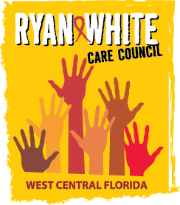
WEST CENTRAL FLORIDA RYAN WHITE CARE COUNCIL
WOMEN, INFANTS, CHILDREN, YOUTH AND FAMILIES COMMITTEE
GOTOWEBINAR
THURSDAY, MAY 27, 2021
10:00 AM – 11:30 AM

AGENDA

- Call to Order Chair

- Roll Call Staff

- Changes to Agenda Members

- Review Minutes Chair
April 22, 2021 (Attachment)

- Care Council Report Members/Staff

- Moment of Inspiration Members
- In-Person Meetings Members
- Women/Youth Concerns/Updates Members

- Community and Client Concerns/Announcements Members/Guests

- Adjournment Chair

Note: Due to the Sunshine Laws, there will be no voting during virtual meetings.
The next meeting of the Ryan White Care Council will be on June 2, 2021 from 1:30 pm to 3:30 pm. The location is Metro Inclusive Health.
The CARE COUNCIL website is operating at www.thecarecouncil.org. Agendas and minutes will be posted on this website.

