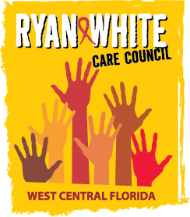
WEST CENTRAL FLORIDA RYAN WHITE CARE COUNCIL
WOMEN, INFANTS, CHILDREN, YOUTH AND FAMILIES COMMITTEE
GOTO MEETING
THURSDAY, JULY 22, 2021
10:00 AM – 11:30 AM

AGENDA

- Call to Order Chair

- Roll Call Staff

- Changes to Agenda Members

- Adoption of Minutes Chair
October 22, 2020 (Attachment)
January 28, 2021 (Attachment)
February 25, 2021 (Attachment)
March 25, 2021 (Attachment)
April 22, 2021 (Attachment)
May 27, 2021 (Attachment)
June 24, 2021 (Attachment)

- Care Council Report Members/Staff

- Moment of Inspiration Members
- Election of Committee Co-Chair Members
- Women/Youth Concerns/Updates Members

- Community and Client Concerns/Announcements Members/Guests

- Adjournment Chair

Note: Action items are in bold.

The next meeting of the Ryan White Care Council will be on August 4, 2021 from 1:30 pm to 3:30 pm at Metro Inclusive Health in St. Pete.
The CARE COUNCIL website is operating at www.thecarecouncil.org. Agendas and minutes will be posted on this website.

