HIV/AIDS Care Continuum for the

Tampa- St. Petersburg Eligible Metropolitan Area

2020

Rob Marlowe, Board Chair

Elizabeth Rugg, Executive Director

Naomi Ardjomand-Kermani, Ryan White Planning Manager

Who We Are

The health councils were created in 1983 by Florida Statute to identify, address and resolve health care issues of local concern. Each health council is a private, non-profit organization governed by a Board of Directors. The Board members are appointed by County Commissioners to represent the concerns of health care consumers, providers, and purchasers.

The Suncoast Health Council, Inc. (SHC) serves Pasco and Pinellas counties. The Council has extensive experience working with for-profit and non-profit agencies, public health organizations, consumers and professionals. Collaboration and cooperation are critical to the success of our mission.

We have three strategic goals: (1) support the accessibility of health care and social support systems through comprehensive health planning; (2) obtain and provide education about essential community health challenges and solutions; and (3) participate as collaborative partners to develop and sustain efficient and cost effective service delivery systems.

Suncoast Health Council, Inc.

Board of Directors

Rob Marlowe, Acting Chair

Dr. Grace Levy-Clarke

Mary Ellen Dennis

Melissa Johnson

Eric Smith

Brittany Peters

Nadine Nickeson

Danielle Bierman

Dr. Lawrence Floriani

To Learn More About the Health Council

Visit our website - www.SuncoastHealthCouncil.org

Or Contact Us:

Suncoast Health Council, Inc.

9600 Koger Blvd., Suite 221

St. Petersburg, FL 33702

727-217-7070

727-570-3033 (Fax)
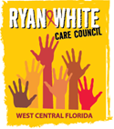

WEST CENTRAL FLORIDA RYAN WHITE CARE COUNCIL

Mission Statement

The mission of the West Central Florida Ryan White Care Council is to manage a high quality, cost-effective, easily accessible, culturally responsive, and comprehensive continuum of care that improves the lives of all individuals living with and impacted by HIV.

Members

Nolan Finn (Chair)
Edward Myles (Vice-Chair)
Joel Carrier
Lisa Conder
Paula Delgado
J. Carl Devine
Kayon Henderson
Vincent Kaborycha
Kamaria Laffrey
Jeffrey Lluberes
Michelle McKinney
Dr. Amanda Miller
Kimberly Molnar
Peggy Wallace
Charles Ware

Produced on behalf of The Ryan White Care Council under contract with the Health Care Services Department within the Human Services of Hillsborough County; Ryan White Program. Funded by HRSA and the State of Florida, Department of Health.

This page is intentionally left blank.
HIV CARE CONTINUUM
The Tampa-St. Petersburg Eligible Metropolitan Area (EMA), located on the west central coast of Florida, is comprised of Hernando, Hillsborough, Pasco, and Pinellas Counties. Figure 1 depicts the Eligible Metropolitan Area’s (EMA) population-based HIV Care Continuum. The graph was developed using HIV/AIDS Surveillance data from the Florida Department of Health.
Definitions and data sources for the Care Continuum are:
- HIV Diagnosed = Include persons whose HIV diagnosis occurred during the period specified, data as of 6/30/2020.
- In Care = People with HIV (PWH) with at least one documented viral load (VL) or cluster of differentiation 4 (CD4) lab, medical visit, or prescription from 1/1/2019 through 3/31/2020, data as of 6/30/2020.
- Retained in Care = PWH with two or more documented VL or CD4 labs, medical visits, or prescriptions at least three months apart from 1/1/2019 through 6/30/2020, data as of 6/30/2020.
- Viral Load Suppression = PWH with a suppressed VL (<200 copies/mL) on the last VL from 1/1/2019 through 3/31/2020, data as of 6/30/2020.

Limitations of this data include:
- Ensuring that all 132,442 People with HIV, 116,689 of which are aware of their status, that are presumed alive and living in Florida in eHARS are valid.
- These data are generated from the merging of the following databases: enhanced HIV/AIDS Reporting System (eHARS) database, Florida’s CAREWare database, and the AIDS Drug Assistance Program (ADAP) database. The analysis of these data depends on the completeness of laboratory reporting in eHARS, maintaining timely reporting of deaths, maintaining accurate current addresses, and accommodating for in and out migration.
- Assuming that persons not in care, based on the data, matches above are truly not in care.
- The diagnosed-based HIV Care Continuum approach was utilized as the estimated number of those who have not been diagnosed with HIV in the EMA was unavailable.

Figure 1: Number and Percentage of PWH
Engaged in Selected Stages of the Continuum of HIV Care
Tampa-St. Petersburg EMA (excl. DOC*)

- 15,834 are estimated to be living with HIV, accounting for 13.5% who are unaware of their status
- 92% of the 537 diagnosed with HIV in 2019 had documented HIV-related care within 3 months of diagnosis
- 87% of People with HIV in care had a suppressed viral load
- 90% of People with HIV retained in care had a suppressed viral load
* Department of Corrections
Source: Florida Department of Health, Tampa-St. Petersburg EMA Epidemiological Profiles CY 2019
In the following three graphs, disparities among the viral suppression rates for three of the most disproportionately impacted minority populations are highlighted:
The poverty rate among many Black populations is high. The socioeconomic issues associated with poverty, such as lack of access to high-quality health care, safe and stable housing, and inclusive, comprehensive, and culturally appropriate HIV prevention education all increase Black populations’ vulnerability to HIV and comorbid health risk. The graph was developed using HIV/AIDS Surveillance data from the Florida Department of Health. Figure 2 depicts the EMA’s HIV Care Continuum for Black People with HIV. In 2019, Black People with HIV made up 37% of HIV cases among all People with HIV, although Black persons made up only 12% of the EMA’s total population. This disparity reflects the marginalized social status of Black populations in the United States, which is further exaggerated by the stigmatization of HIV, identifying as a gender or sexual minority-based discrimination, medical mistrust, and the fear of mistreatment. As shown in Figure 2, viral suppression rates among these populations, within the Tampa-St. Petersburg EMA, are low overall (68%), but increases 18% if the Person with HIV is retained in HIV-related care.
Figure 2: Number and Percentage of Black PWH
Engaged in Selected Stages of the Continuum of HIV Care
Tampa-St. Petersburg EMA (excl. DOC)

- 90% of the 208 Black persons diagnosed with HIV in 2019 had documented HIV-related care within 3 months of diagnosis
- 79% of Black People with HIV in care had a suppressed viral load
- 86% of Black People with HIV retained in care had a suppressed viral load

Source: Florida Department of Health, Tampa-St. Petersburg EMA Epidemiological Profiles CY 2019
Socioeconomic barriers such as homophobia, stigma, and lack of access to quality health care especially affect Black cisgender men who engage in male-to-male sexual contact (MMSC).
These barriers to care, combined with a fear of discrimination and a lack of accessible, comprehensive, and inclusive safer sex education, may prevent cisgender men who engage in MMSC of all races/ethnicities from seeking HIV testing and treatment. As a result, cisgender men who engage in MMSC are more vulnerable to HIV. Figure 3 depicts the EMA’s HIV Care Continuum for cisgender male-to-male sexual contact (MMSC). In 2019, MMSC made up 75% of all cisgender men living with HIV and 57% of the total number of HIV cases in the EMA. The graph was developed using HIV/AIDS Surveillance data from the Florida Department of Health. As is seen in Figure 3, 92% of PWH who engage in MMSC were virally suppressed when retained in care, as compared to viral suppression among the overall population of PWH who engage in MMSC (77%), within in the EMA.
Figure 3: Number and Percentage of PWH Who Engage in Cisgender MMSC
Engaged in Selected Stages of the Continuum of HIV Care
Tampa-St. Petersburg EMA (excl. DOC)

- 93% of the 335 PWH who engage in MMSC diagnosed with HIV in 2019 had documented HIV-related care within 3 months of diagnosis
- 77% of PWH who engage in MMSC in care had a suppressed viral load
- 92% of PWH who engage in MMSC retained in care had a suppressed viral load

Source: Florida Department of Health, Tampa-St. Petersburg EMA Epidemiological Profiles CY 2019.
In general, receptive sex is the most common mode of HIV transmission among all genders, thus those who engage in MMSC and cisgender women who engage in heterosexual receptive anal and/or vaginal sex are among those most vulnerable to HIV. Some cisgender women, including those in monogamous partnerships, may not be aware of their partners’ sexual and injection drug use behaviors and forgo safer sex practices, such as the use of condoms/barriers, pre-exposure prophylaxis (PrEP), or HIV testing.
Cisgender women who have experienced sexual assault/trauma, and lack familial and/or social support, may also be more likely to engage in survival sex work, increasing their vulnerability to contracting HIV, especially if they are unable access PrEP and/or unable to negotiate condom use with their sexual partners.
Figure 4 depicts the EMA’s HIV Care Continuum for cisgender heterosexual women with HIV. In 2019, heterosexual women made up 19% of the total number of HIV cases, but 68% of all heterosexual People with HIV in the EMA. Once again, as seen in Figure 4, viral suppression is far likelier when PWH are retained in care and this is no different among cisgender heterosexual women. An additional barrier to retention in care is a lack of accessible and affordable childcare. Nationally, cisgender women with HIV are twice as likely (76%) as cisgender men with HIV (34%) to be caring for at least one child under the age of 18. The graph was developed using HIV/AIDS Surveillance data from the Florida Department of Health.
Figure 4: Number and Percentage of Cisgender Heterosexual Women with HIV
Engaged in Selected Stages of the Continuum of HIV Care
Tampa-St. Petersburg EMA (excl. DOC)

- 93% of the 72 Cisgender heterosexual women diagnosed with HIV in 2019 had documented HIV-related care within 3 months of diagnosis
- 73% of Cisgender heterosexual women with HIV in care had a suppressed viral load
- 89% of Cisgender heterosexual women with HIV retained in care had a suppressed viral load
Source: Florida Department of Health, Tampa-St. Petersburg EMA Epidemiological Profiles CY 2019.
SYSTEM-WIDE HIV/AIDS BUREAU (HAB) PERFORMANCE MEASURES
The following are system-wide HAB performance measures for the Tampa – Saint Petersburg EMA (as accessed via CAREWare and e2Hillsborough) through December 2020, based on 6,346 Ryan White clients served.
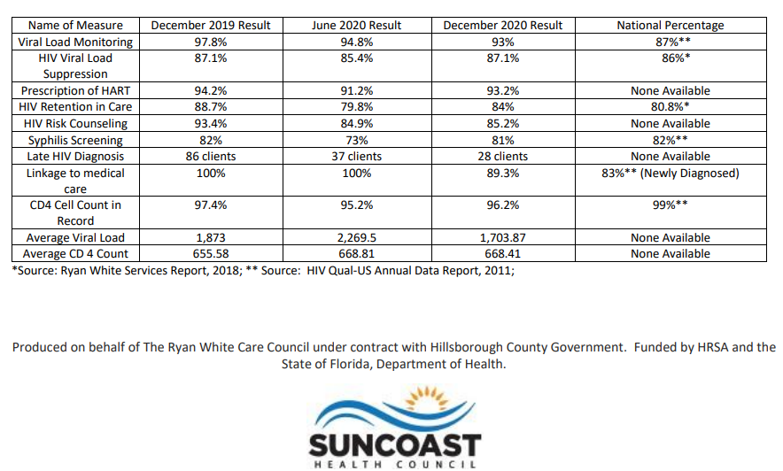

Scharff DP, Mathews KJ, Jackson P, Hoffsuemmer J, Martin E, Edwards D. More than Tuskegee: understanding mistrust about research participation. J Health Care Poor Underserved. 2010;21(3):879-897. doi:10.1353/hpu.0.0323
Matthews DD, Herrick AL, Coulter RW, et al. Running Backwards: Consequences of Current HIV Incidence Rates for the Next Generation of Black MSM in the United States. AIDS Behav. 2016;20(1):7-16. doi:10.1007/s10461-015-1158-z
Cavanaugh CE, Hansen NB, Sullivan TP. HIV sexual risk behavior among low-income women experiencing intimate partner violence: the role of posttraumatic stress disorder. AIDS Behav. 2010;14(2):318-327. doi:10.1007/s10461-009-9623-1
Marshall BD, Shannon K, Kerr T, Zhang R, Wood E. Survival sex work and increased HIV risk among sexual minority street-involved youth. J Acquir Immune Defic Syndr. 2010;53(5):661-664. doi:10.1097/QAI.0b013e3181c300d7
Schuster MA, Kanouse DE, Morton SC, et al. HIV-infected parents and their children in the United States. Am J Public Health. 2000;90(7):1074-1081. doi:10.2105/ajph.90.7.1074

