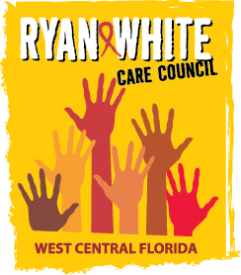
WEST CENTRAL FLORIDA RYAN WHITE CARE COUNCIL
WOMEN, INFANTS, CHILDREN, YOUTH AND FAMILIES COMMITTEE
GOTO MEETING
THURSDAY, JANUARY 27, 2022
10:00 AM – 11:30 AM

AGENDA

- Call to Order Members

- Roll Call Staff

- Changes to Agenda Members

- Review Minutes Members
October 28, 2021

- Care Council Report Members/Staff

- Moment of Inspiration Members

- Spring Event Members
- HIV and Bone Health Staff
- Women/Youth Concerns/Updates Members
  - Reallocations Needs Assessment Survey Results Staff

- Community and Client Concerns/Announcements Members/Guests

- Adjournment Chair

The next meeting of the Ryan White Care Council will be on February 2, 2022 from 1:30 pm to 3:30 pm on GoToMeeting.
The CARE COUNCIL website is operating at www.thecarecouncil.org. Agendas and minutes will be posted on this website.

