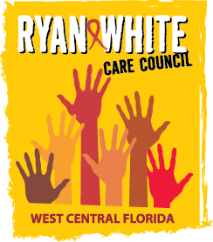
WEST CENTRAL FLORIDA RYAN WHITE CARE COUNCIL
WOMEN, INFANTS, CHILDREN, YOUTH AND FAMILIES WORKGROUP
GOTO MEETING
THURSDAY, OCTOBER 27, 2022
10:00 AM – 11:30 AM

AGENDA

- Call to Order Members

- Roll Call Staff

- Changes to Agenda Members

- Review Minutes Members
September 22, 2022

- Care Council Report Members/Staff

- Moment of Inspiration Members

- Fall Event Planning Members
- Women/Youth Concerns/Updates Members

- Community and Client Concerns/Announcements Members/Guests

- Adjournment Members

The next meeting of the Ryan White Care Council will be on November 2, 2022, from 1:30 pm to 3:30 pm at Metro Inclusive Health in St. Petersburg.
The CARE COUNCIL website is operating at www.thecarecouncil.org. Agendas and minutes will be posted on this website.

