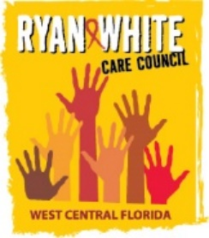
WEST CENTRAL FLORIDA RYAN WHITE CARE COUNCIL
THE CHILDREN’S BOARD OF HILLSBOROUGH COUNTY
WEDNESDAY, NOVEMBER 1, 2023
1:30 P.M. – 3:30 P.M.

MINUTES

CALL TO ORDER | The meeting of the Ryan White Care Council was called to order by E.S. Myles, Chair, at 1:31 p.m.
ROLL CALL AND INTRODUCTIONS | See attached attendance list.  Myles asked members to share a special holiday memory or favorite thing to do around the holidays.
CHANGES TO AGENDA | There were no changes to the agenda.
MOMENT OF SILENCE | Myles led everyone through a moment of silence, asking everyone to honor those who know their status and those who do not yet know their status.
ADOPTION OF MINUTES | Staff, Katie Scussel, said that she had made one grammar correction, on page seven, after the minutes were sent out.  The minutes from October 4, 2023 were approved (M: Molnar, S: Finn) (14 yes, 0 no, 0 abstain).
CHAIR/VICE CHAIR’S REPORT | Chair, E.S. Myles, reported that his organization, We Are The Change, is having an event on November 18th. There will be a clothing drive, food, and they are hoping to provide showers. The Hillsborough County Planning Committee is having a World AIDS Day event on December 1st, Code Red Affair. Organizers will be recognizing members of the community, including advocates, case managers, peers, and others. Myles encouraged everyone to attend.
RECIPIENT’S REPORT | Part A Recipient, Aubrey Arnold, reported that there are several projects currently in progress. The Part A Request for Applications (RFA) was released on October 4th. Most Part A services are currently out for bid. The RFA is posted on the Hillsborough County website. Applications are due November 14th. Aubrey and his staff are currently in the process of securing the scoring team. There should be close to forty people scoring applications. Aubrey went on to say that he is looking forward to the new scoring process through e2-Hillsborough. His team did extensive testing on the e2 portal over the summer and it should be a great enhancement to the process. The entities who receive funding should be announced November 30th or December 1st. Following the initial announcement, there will be a round of negotiations, then new contracts will start March 1, 2024.  Staff at Hillsborough County are also working internally and with subrecipients to prepare for the upcoming site visit for Ending the HIV Epidemic (EHE). The site visit will be during the first week of December. The Part A site visit will be in June of 2024. There will be more information about the upcoming Part A site visit in the spring.  November 1st is the first day of open enrollment for the Health Insurance Marketplace. Enrollment will be open through January 15, 2024. The AIDS Drug Assistance Program (ADAP) will be supporting 137 plans this year, which is up from 133 plans last year. Aubrey said that Part A has distributed information to case managers on the open enrollment process.  The next Florida Comprehensive Planning Network (FCPN) meeting will be the first week of December in Tampa at the Embassy Suites near the University of South Florida. This will be a busy week as it is the same week as the EHE site visit and the next Care Council meeting.  To close his report, Aubrey honored long-term Care Council member, J. Carl Devine, who recently celebrated his 80th birthday. Aubrey recognized J. Carl for the great work he does for the community. Myles let everyone know that October 19th is officially J. Carl Devine Day.  Nolan Finn asked for more information about the Part A scoring process. Applications will be distributed to scorers on November 15th, the day after they are due. Consensus scoring will be done through Microsoft Teams on November 30th. Nolan expressed his disappointment in not being able to participate in the scoring this year, but HRSA has clarified that Planning Council members may not serve on scoring teams. Nolan emphasized the importance of the process and the need for community involvement. Aubrey said that there would be a training the following week for scorers, which will be recorded so if people need to miss the training they can watch it later.
LEAD AGENCY REPORT | For the Part B report, Joshua Cardwell announced that as a result of review over the last several months, the Florida Department of Health has decided to proceed with Part B following a statewide fiduciary agent model for the distribution of Part B funds. There is not yet an implementation plan or timeline for the change in model. Kim Molnar commented that The AIDS Institute has some information available on their website and that more information will be given during the upcoming FCPN meeting in December. The state intends to continue with the models that areas are using now until confident that the statewide model is ready, so as not to disrupt any services for clients.
HOUSING OPPORTUNITIES FOR PEOPLE WITH HIV/AIDS (HOPWA) REPORT | Anne Cronyn, a member of the Membership and Community Outreach Committee, encouraged members to stay for the training following the meeting. She said she knows it will be excellent because she was able to attend a similar presentation by Nick Armstrong at the United States Conference on HIV/AIDS in September.  Anne went on to report that the Department of Housing and Urban Development (HUD) is currently taking applications for HOPWA competitive funds. The City of Tampa will not be applying for these funds as a grantee, but this is a good opportunity for some non-profits in the community to apply directly for funds. There is more information available on HUD.gov. Anne also reported that the Tampa City Council did approve rental assistance money again, but that she did not yet have any details.
CARE COUNCIL PLANNING SUPPORT (PCS) STAFF REPORT | Planning Council Support Staff, Katie Scussel, encouraged members to stay for the training following the meeting. She then let members know that she would be going on maternity leave in late January and expecting to be back by the April meeting. Members congratulated Katie.
COMMITTEE/WORKGROUP REPORTS | B. Resource Prioritization and Allocation Recommendations Committee (RPARC) – Nolan Finn, Chair  RPARC met on October 12, 2023 at Empath Health in Clearwater. The committee voted on FY Part A 2023-2024 Reallocation Recommendations and Carryover Allocations. The committee also reviewed Part B expenditure reports and heard an update on the Assessment of the Administrative Mechanism (AAM).  1. Part A FY 2023-2024 Reallocation Recommendations  Nolan briefly went over the Reallocation Recommendations. Part A has recommended decreasing Oral Health in Pinellas by $20,000. Nolan explained that there have been difficulties with spending in this service category. Part A also recommended decreasing Outpatient Ambulatory Health Services (OAHS) in Hernando, due to difficulty with spending within that contract.  Background  The Care Council is responsible for approving the reallocation of Part A funding. The following funding recommendations were made by the Resource Prioritization and Allocation Recommendations Committee (RPARC), based on the Part A Recipient’s assessment of unmet need. A total of $65,000 is recommended to be reallocated to Medical Case Management and Mental Health.  Action Required  THAT THE CARE COUNCIL ADOPT THE PART A FY 23-24 FUNDING REALLOCATIONS AS FOLLOWS:  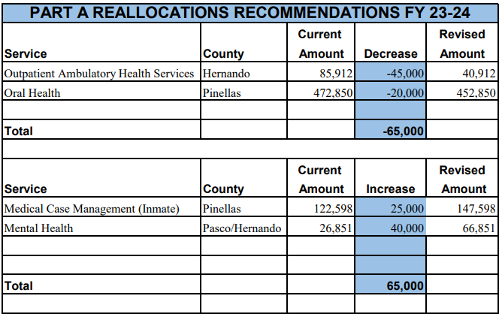  Members voted via roll call vote to approve the Part A FY 2023-2024 Reallocation Recommendations (M: Finn S: Devine) (14 yes, 0 no, 0 abstain).  2. Part A FY 2024-2025 Carry Over Allocation Recommendations  Nolan presented the Carry Over Allocation Recommendations. Nolan explained that the carry over received from last fiscal year is the largest carry over the program has received in a long time but said that Part A is confident in the ability to reabsorb these funds. The Recipient put out a survey to providers to determine where more funding was needed, and the feedback received was that several providers asked for more funds than was available.  Background  The Care Council is responsible for approving the allocation of Part A funding. The following funding recommendations were made by the Resource Prioritization and Allocation Recommendations Committee (RPARC), based on the Part A Recipient’s assessment of unmet need. A total of $446,680 of carry over funding from the last fiscal year is recommended to be allocated to Medical Case Management and Mental Health.  Action Required  THAT THE CARE COUNCIL ADOPT THE PART A FY 23-24 CARRY OVER ALLOCATIONS AS FOLLOWS:  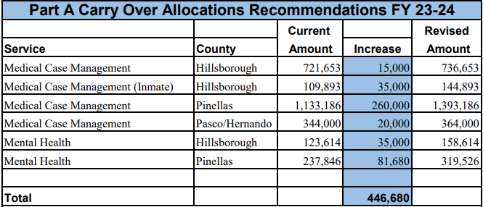  Members voted via roll call vote to approve the Part A FY 2023-2024 Carry Over Allocation Recommendations (M: Finn S: Devine) (14 yes, 0 no, 0 abstain).  3. Assessment of the Administrative Mechanism  David Cavalleri gave a brief update about the 2022-2023 Assessment of the Administrative Mechanism (AAM). He said he had been able to conduct more interviews with providers and would be providing a longer update in January.  C. Membership and Community Outreach – Abigail Dees, Staff  Membership and Community Outreach met on October 16, 2023 at the Children’s Board. The committee recommended two items for voting.  1. Membership Application – Anthony Trunzo  Background  The Membership Committee has reviewed the membership application of Anthony Trunzo. He is being recommended for voting membership on the Care Council based on his application scores, interview assessment, and the HRSA (Health Resources and Services Administration) category that he will fill.  Action Required  The Committee recommends that the Care Council members adopt the following recommendation:  THAT THE COUNCIL ACCEPTS THE NOMINATION OF ANTHONY TRUNZO AS A VOTING MEMBER REPRESENTING HILLSBOROUGH COUNTY (2023-2026). THE COUNCIL WILL FORWARD THE NOMINATION TO HILLSBOROUGH COUNTY BOARD OF COUNTY COMMISSIONERS FOR FINAL APPROVAL.  Anthony Trunzo introduced himself and said he was a pharmacist with Bell Pharmacy, an independent LGBT-owned pharmacy in St. Pete.  Members voted to approve the membership of Anthony Trunzo (M: Finn S: Devine) (14 yes, 0 no, 0 abstain).  Members welcomed Anthony onto the Care Council.  2. Member Removal – Vincent Kaborycha  Background  The Membership Committee has reviewed the attendance of current Care Council members. In accordance with the Care Council bylaws members should not miss more than three meetings within a year. Members are also required to name an alternate that can vote in their absence, but an alternate can only be sent three times in a members place. Members who do not comply with Care Council bylaws may be subject to removal. Members not in compliance with these guidelines are contacted inquiring about their absences and their desire to remain a voting member of the Care Council.  Excused absences may be granted from the Care Council Chair for illness and all members are encouraged to notify staff of the reason for an absence. The Membership Committee has taken into consideration communication from members before making recommendations for removal.  Action Required  The Committee recommends that the Care Council members adopt the following recommendations:  REMOVE VINCENT KABORYCHA AS A VOTING MEMBER OF THE CARE COUNCIL DUE TO POOR ATTENDANCE.  Members voted to remove member Vincent Kaborycha (M: Devine S: Finn) (14 yes, 0 no, 0 abstain).  Nolan said that he was sorry to see him go and that he had been a great voice on the Care Council and had served in leadership roles. Vince will be eligible to reapply in the future if he would like to join again.
COMMUNTIY INPUT/  ANNOUNCEMENTS | Nolan announced that on November 4th there will be a Bungalow Fest in Historic Kenwood in St. Pete. Attendees will be able to tour ten homes in the community.  Kim Molnar announced that FCPN is meeting in-person December 4-6th in Tampa. There will be a virtual option available for attendees as well. Kim said it is a great opportunity to learn about things going on with HIV in Florida. Members can get in touch with Kim if they would like to attend.  J. Carl Devine announced that his organization, Banyan Tree Project, is hosting a World AIDS Day event Saturday, December 2nd on the Deuces in St. Pete from 1:00 pm to 4:00 pm. If anyone wants to participate, they can get in touch to receive the vendor form.
ADJOURNMENT | There being no further business to come before the Care Council, the meeting was adjourned at approximately 2:18 p.m. The meeting was immediately followed by a training from Nick Armstrong with The AIDS Institute on HIV funding in the federal budget and the legislative process.
Note: A recording of the meeting is available by request | For further details about this Care Council meeting, please visit thecarecouncil.org to access meeting minutes and handouts.
LIST OF HANDOUTS AND ATTACHMENTS | - November 1, 2023 Agenda  - October 4, 2023 Minutes  - Background – Part A Reallocation Recommendations  - Background – Part A Carry Over Allocations  - 2022-2023 Assessment of the Administrative Mechanism  - Background – New Member – Anthony Trunzo  - Background – Member Removal – Vincent Kaborycha  - November 2023 Meeting Calendar
WEBSITES CITED | None

Attendance
Care Council Members | Attendance
(Myles) Edward Myles (Chair) | In-person
Rachel Brown (Vice-Chair) | Virtual
Lillie Bruton | ALT
Joel Carrier
Anne Cronyn | In-person
J Carl Devine | In-person
Nolan Finn | In-person
Ashley Hill | Virtual
Nataliya Johnson | In-person
Riley Johnson
Angela Kellogg | ALT
Nicole Kish | In-person
Kamaria Laffrey
Jeffrey Lluberes | ALT
Bernice McCoy
Marylin Merida | ALT
Antonio Miles | In-person
Kim Molnar | In-person
Teriko Perkins
Anthony Trunzo | In-person
Peggy Wallace | In-person
Bernard Washington
Associate Members | Attendance
Chris Gudis
Recipient Staff | Attendance
Aubrey Arnold | In-person
Dorinda Creighton-Seth
Maria Teresa Jaureguizar
Lead Agency Staff | Attendance
Joshua Cardwell | In-person
Nicole Houston
Health Council Staff | Attendance
Abigail Machtel | In-person
Lisa Nugent | In-person
Katie Scussel | In-person
Regular Guests | Attendance
David Cavalleri | Virtual
Emily Hughart | Virtual
Elizabeth Rugg
Guests | Attendance
Nick Armstrong | Virtual
Holly Beaver | In-person
Lisa Conder | Virtual
Dave Cousineau | In-person
Julia Delmerico | In-person
Sheryl Hoolsema | In-person
Allyson Jones | In-person
Teresa Kelly | In-person
Kristen Lewis | Virtual
Darius Lightsey | Virtual
Mike Neuges | Virtual
Indira Palomino | In-person
Michelle Scavnicky | Virtual
Barbara Szelag | In-person

ALT= Alternate present EX = Excused

I, Chair E.S. Myles, do certify that these minutes have been approved by me and the members of the Care Council on this day, December 6, 2023.

E.S. Myles, Chair: ________________________________________________

