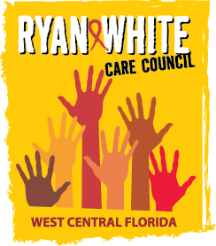
WEST CENTRAL FLORIDA RYAN WHITE CARE COUNCIL
RESOURCE PRIORITIZATION AND ALLOCATION RECOMMENDATIONS (RPARC)
EMPATH HEALTH, CLEARWATER
THURSDAY, MAY 9, 2024
11:00 A.M. - 12:30 P.M.

AGENDA

- Call to Order Chair

- Roll Call/Introductions Staff/Members

- Changes to Agenda Members
- Adoption of Minutes Members
1. March 14, 2024 (Attachment)

- Care Council Report Chair

VI. Part A Recipient Update Arnold
- Part A FY 2023-2024 Final Expenditure Report

VII. Part B Lead Agency Update Cardwell/Houston

VIII. Community Input/Announcements Members/Guests

IX. Adjournment Chair

Note: Items in bold are action items.
The next RPARC meeting will be on June 13, 2024 at Empath Health in Clearwater. The Ryan White Care Council meeting will be on June 5, 2024 at the Children’s Board of Hillsborough County.

PLEASE REMEMBER: Florida's SUNSHINE LAW requires that meetings are noticed and open to the public, and that minutes are taken at each meeting. For the Care Council, this means that meetings are advertised in advance and members of the public are welcome to attend and participate in public comment. Notes are taken to make sure a record of the meeting is made so anyone can read what action was taken.
The SUNSHINE LAW does not allow members of the same council or committee to talk to each other outside of a publicly noticed meeting about matters that might come before the Council for a vote. For the Care Council, this means that every member of the Council must decide how to vote on their own and must make sure not to discuss upcoming agenda items or other council matters with other council members.
The CARE COUNCIL website is at www.thecarecouncil.org.
Agendas and minutes will be posted on this website.

