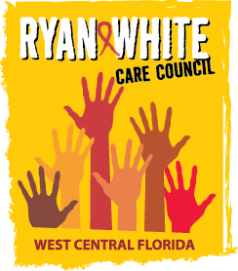
WEST CENTRAL FLORIDA RYAN WHITE CARE COUNCIL
RESOURCE PRIORITIZATION AND ALLOCATION RECOMMENDATIONS (RPARC)
EMPATH HEALTH, CLEARWATER
THURSDAY, JUNE 12, 2025
11:00 A.M. - 12:30 P.M.

AGENDA

- Call to Order Chair

- Roll Call/Introductions Staff/Members

- Changes to Agenda Members
- Adoption of Minutes Members
1. April 10, 2025

- Care Council Report Chair

VI. Part A Recipient Update Arnold
A. Part A FY 2024-2025 Final Expenditure Report

VII. Part B Lead Agency Update Cardwell/Houston
A. Part B Federal FY 2024-2025 Final Expenditure Report
B. Part B State FY 2024-2025 Expenditure Report

VIII. Meeting Location Members/Staff

IX. Community Input/Announcements Members/Guests

X. Adjournment Chair

Note: Items in bold are action items.
The next RPARC meeting will be on July 10, 2025 at Empath Health in Clearwater. The Ryan White Care Council meeting will be on July 2, 2025 at Lee Davis Community Resource Center.

PLEASE REMEMBER: Florida's SUNSHINE LAW requires that meetings are noticed and open to the public, and that minutes are taken at each meeting. For the Care Council, this means that meetings are advertised in advance and members of the public are welcome to attend and participate in public comment. Notes are taken to make sure a record of the meeting is made so anyone can read what action was taken.
The SUNSHINE LAW does not allow members of the same council or committee to talk to each other outside of a publicly noticed meeting about matters that might come before the Council for a vote. For the Care Council, this means that every member of the Council must decide how to vote on their own and must make sure not to discuss upcoming agenda items or other council matters with other council members.
The CARE COUNCIL website is at www.thecarecouncil.org.
Agendas and minutes will be posted on this website.

