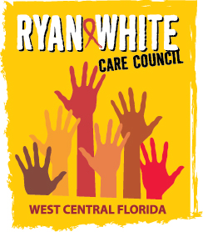
WEST CENTRAL FLORIDA RYAN WHITE CARE COUNCIL
WOMEN, INFANTS, CHILDREN, YOUTH AND FAMILIES WORKGROUP
ZOOM
THURSDAY, SEPTEMBER 25, 2025
10:00 AM – 11:30 AM

AGENDA

- Call to Order Members

- Roll Call Staff

- Changes to Agenda Members

- Review Minutes Members
July 24, 2025

- Care Council Report Members/Staff

- Moment of Inspiration Members
- Women’s Event Members

- Women/Youth Concerns/Updates Members

- Community and Client Concerns/Announcements Members/Guests

- Adjournment Members

The next meeting of the Ryan White Care Council will be on October 1, 2025 from 1:30 pm to 3:30 pm at the Lee Davis Community Center.

The next WICY&F Meeting will be on January 22, 2026 at 10:00 am via ZOOM.

The CARE COUNCIL website is operating at www.thecarecouncil.org. Agendas and minutes will be posted on this website.

