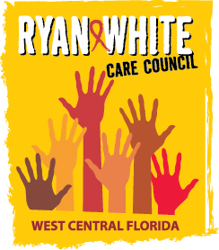
WEST CENTRAL FLORIDA RYAN WHITE CARE COUNCIL
WOMEN, INFANTS, CHILDREN, YOUTH AND FAMILIES WORKGROUP
ZOOM
THURSDAY, MAY 28, 2026
10:00 AM – 11:30 AM

AGENDA

- Call to Order Members

- Roll Call Staff

- Changes to Agenda Members

- Review Minutes Members
September 25, 2025

- Care Council Report Members/Staff

- Work Plan Members

- Meeting Time, Date, and Location Members

- Women/Youth Concerns/Updates Members
- Community and Client Concerns/Announcements Members/Guests

- Adjournment Members

The next meeting of the Ryan White Care Council will be on June 3, 2026 from 1:30 pm to 3:30 pm at Lee Davis Community Resource Center.

The next WICY&F Meeting will be on July 23, 2026 at 10:00 am via ZOOM.

The CARE COUNCIL website is operating at www.thecarecouncil.org. Agendas and minutes will be posted on this website.

