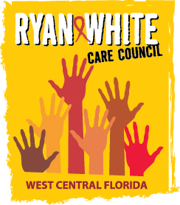

WEST CENTRAL FLORIDA RYAN WHITE CARE COUNCIL
RESOURCE PRIORITIZATION AND ALLOCATION
RECOMMENDATIONS COMMITTEE (RPARC)
EMPATH HEALTH, ST. PETE
THURSDAY, JUNE 11, 2026
11:00 A.M. – 12:30 P.M.

MINUTES
CALL TO ORDER | The meeting was called to order by Nolan Finn, Chair, at 11:02 a.m.
ATTENDANCE | Members Present: John Acevedo, Lillie Bruton (virtual), Nolan Finn, Kevin Williams (virtual), Joy Winheim (virtual)  Members Absent: Angela Kellogg, Nicole Kish, Bernice McCoy, Marylin Merida  Guests Present: None  Recipient Staff Present: Aubrey Arnold, Dorinda Lynn (virtual)  Lead Agency Staff Present: Alix Winston  Suncoast Health Council Staff Present: Katie Scussel
CHANGES TO AGENDA | There were no changes.
ADOPTION OF MINUTES | Members voted to approve the minutes from April 9, 2026 (M: Winheim, S: Acevedo).
CARE COUNCIL REPORT | The Care Council met on June 3, 2026 at Lee Davis Community Resource Center. Aubrey Arnold shared that Hillsborough County has received its full Ryan White Part A and Ending the HIV Epidemic (EHE) grant awards. The Part A program was funded at $10,979,710 which was an increase of approximately $329,000 from the previous year. The EHE award was $2,725,757 which was an increase of approximately $309,000 from the previous year. The Tampa-St. Petersburg EMA was the only area in Florida and one of only seven jurisdictions nationally to receive an increase in EHE funding. Aubrey that the EMA has consistently demonstrated its ability to fully expend grant funds each year. Aubrey also provided an update on the recent ADAP changes. He shared that the situation has largely stabilized following the special legislative session, during which the Florida legislature allocated $75 million to fully fund ADAP. Biktarvy has been restored to the ADAP formulary and the eligibility criteria is back to 400% federal poverty level (FPL). The only component that has not been restored is health insurance premium assistance. There is also now an annual cap on how many clients the program may serve, which may have impacts down the road.  For the Lead Agency report, Alix Winston shared that the Florida Department of Health in Pinellas is working on a shared services agreement with the Hillsborough County DOH pharmacy to be able to provide medications for clients in Area 14 (Polk, Hardee, and Highlands). The Lead Agency is currently working on spending down the budget. Approximately 33% of the federal funds and 31% of state funds remain.  For the HOPWA report, Anne Cronyn shared that the City of St. Pete has received HOPWA funds and the service area that the City of Tampa oversees will now be split between the two cities. The City of Tampa’s HOPWA reward was reduced this year by around the same amount as was awarded to St. Pete. There will be more information shared soon.  Members voted to approve bylaw updates, two associate members, the full draft of the Integrated Plan, and the addition of some over the counter items back onto the Part A formulary.  The next meeting will be on July 1, 2026 at Lee Davis Community Resource Center.
PART A RECIPIENT UPDATE | Aubrey reported that additional funding has become available for services, due to the increases in the Part A award and the EHE award. He conducted a survey of providers to determine unmet need.  Aubrey reviewed proposed FY 2026-2027 Allocations/Reallocations. EHE allocations were provided as an informational item, even though RPARC does not have purview over these funds. He explained that in addition to the increased funding available through increases to the Part A and EHE awards, there are also funds previously allocated to LPAP that providers indicated were no longer needed. These funds were proposed for reallocation to other service categories.  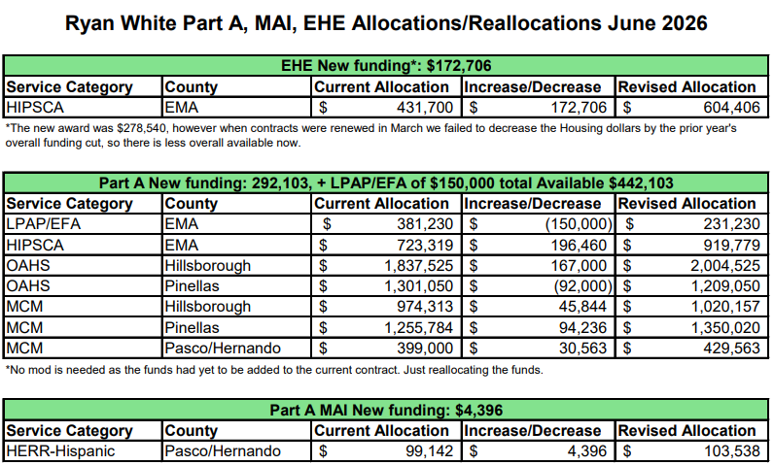  Members discussed the proposed reallocations and reviewed the rationale for the funding recommendations. Aubrey noted that while additional funding was available, requests exceeded available resources and some requests, including additional funding for mental health services, could not be fully accommodated.  Nolan Finn asked whether the proposed allocation for Health Insurance Cost Sharing Assistance (HICSA) would be sufficient to meet projected needs. Aubrey answered that HICSA is expected to be fully funded through a combination of Part A and EHE funds.  Members also discussed the impact of recent state legislative appropriations related to ADAP. Aubrey noted that while the Legislature allocated additional funding, the appropriation does not address health insurance premium assistance, so more clients may need to be assisted with local funds to maintain health insurance coverage.  Members also discussed the proposed reallocations in Outpatient Ambulatory Health Services (OAHS). Aubrey explained that the shift between Hillsborough and Pinellas counties is an internal shift from one provider.  Nolan asked for more information on what is happening with Medical Case Management (MCM) for MCM providers to continue asking for additional funds. Dorinda Lynn explained that increases were due to increased client loads, noting that one OAHS provider also noted increased clients.  Members voted to approve the FY 2026-2027 Part A Reallocation Recommendations (M: Bruton, S: Acevedo).
PART B LEAD AGENCY UPDATE | Alix Winston reported that the Florida Department of Health in Pinellas is currently processing contract amendments to expand services in several areas, including Emergency Financial Assistance (EFA), Mental Health Services, and Health Insurance Cost Sharing Assistance (HICSA). Additional amendments are intended to improve service coverage in rural areas.  Alix reported that she and Nicole Houston are working on a shared services agreement with the Hillsborough DOH pharmacy to provide medications in the outlying areas. There are no other similar agreements available in Florida so they are working closely with legal counsel to ensure the agreement is executed correctly.  Alix shared that state funding is expected to be fully expended by the end of the grant year. While May expenditure data was not yet available, projections indicate that spending is on track. Approximately 23% of federal funding remains and is expected to roll forward.
COMMUNITY INPUT/ ANNOUNCEMENTS | Aubrey announced that the quarterly provider meeting is scheduled for June 26, 2026 and will be held virtually. A Microsoft Teams invitation will be distributed to providers.  Nolan announced that the next Quality Management meeting will be held on June 18, 2026 and will take place on Thursday rather than Friday, because of Juneteenth.
ADJOURNMENT | There being no further business to come before the committee, the meeting was adjourned at 11:38 p.m.

