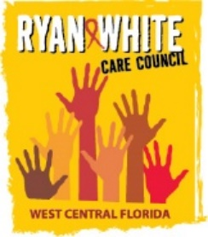
WEST CENTRAL FLORIDA RYAN WHITE CARE COUNCIL
LEE DAVIS COMMUNITY RESOURCE CENTER
WEDNESDAY, JULY 1, 2026
1:30 P.M. – 3:30 P.M.

MINUTES

CALL TO ORDER | The meeting of the Ryan White Care Council was called to order by E.S. Myles, chair, at 1:36 p.m.
ROLL CALL, INTRODUCTIONS, AND ICE-BREAKER | As an icebreaker, Bernice McCoy, vice chair, asked members to share which teams they were rooting for in the World Cup.
CHANGES TO AGENDA | There were no changes to the agenda.
MOMENT OF SILENCE | Bernice led everyone through a moment of silence in honor of those we've lost and those affected by HIV. She also asked people to honor those affected by the recent earthquake in Venezuela.
ADOPTION OF MINUTES | Members reviewed the minutes for the June 3, 2026 meeting.  The meeting minutes from June 3, 2026 were approved (M: Cronyn, S: Finn) (13 yes, 0 no, 0 abstain).
CHAIR/VICE CHAIR’S REPORT | Myles shared some upcoming community events, including one for Southern HIV Awareness Day at Casa V in Ybor. The Hillsborough County Planning Committee is also in the process of planning an event for World AIDS Day.  Bernice announced that Tampa General Hospital has a new PrEP navigation program in the emergency department. She introduced Taylor Solarsky, who is working on the project.
RECIPIENT’S REPORT | Aubrey Arnold reported that Governor DeSantis was just in Tampa to sign the state budget. He shared that the AIDS Drug Assistance Program (ADAP) has been restored with the exception of health insurance premium assistance.  Aubrey thanked Katie Scussel for her work on the Integrated Plan, which was submitted to HRSA on June 25th. He also reported that the Recipient's Office continues working to streamline the programmatic and fiscal monitoring process and expressed that he hopes providers will appreciate the improved process.  Hillsborough County staff will be attending the upcoming Ryan White Conference in Washington, D.C. August 4-7, 2026.
LEAD AGENCY REPORT | Nicole Houston thanked those who attended the recent Pinellas Ending the HIV Epidemic (EHE) meeting.  Nicole reported that the Lead Agency is working on contract amendments to expand Emergency Financial Assistance (EFA) and insurance premium assistance in the outer counties.
HOPWA REPORT | Anne Cronyn reported that Pinellas County will now be served under a new jurisdiction. She explained that the City of St. Petersburg will become responsible for administering services in Pinellas County, while the City of Tampa will continue serving Hillsborough, Pasco, and Hernando counties. Anne reported that she has been receiving technical assistance from HUD along with staff from the City of St. Pete to ensure a smooth transition. Tampa may continue administering the funds in Pinellas while St. Pete works to do some capacity building to be ready to administer funds. Anne said that there will be some kind of memorandum of agreement but that the details are still being worked out.  Nolan Finn asked how the changes would affect the recent Request for Applications (RFA). Anne responded that the City of Tampa plans to move forward with an RFA for Hillsborough, Pasco, and Hernando counties.
CARE COUNCIL PLANNING STAFF REPORT | Katie Scussel, staff, shared that a staff member from CAN’s social media team was present at the meeting to shoot some video for social media promoting the Care Council. Katie said that a member had shared some concerns about the project. Kevin Williams shared that he felt it was inappropriate and that it would appear that CAN was using the Care Council for their own promotion or marketing. Aubrey reminded members that all Care Council meetings are public under Sunshine Law and that any agency is allowed to film or post information about the meetings on social media. Staff from CAN shared that they were only intending to promote the Care Council and assist with recruitment. Members discussed the need for recruitment efforts. Several members shared their perspectives and did not have issues with the video, as long as it promoted the Care Council and emphasized the importance of getting involved.  Katie presented the 2026-2027 All Committee Workplan. All committees have updated their work plans for the year except for WICY&F, which has not had consistent attendance at their meetings. Katie also presented the 2026-2027 Care Council Work Product Schedule, highlighting the timing for major work items.
COMMITTEE/WORKGROUP REPORTS | A. Planning and Evaluation Committee (P&E) -- Nolan Finn, Committee Co-Chair  Planning and Evaluation did not meet in June. The next meeting will be on July 9, 2026 at EPIC in St. Pete.  B. Resource Prioritization and Allocation Recommendations Committee (RPARC) – Nolan Finn, Committee Chair  Nolan reviewed the FY 2026-2027 Part A allocation and reallocation recommendations.  Nolan explained that the Recipient’s office surveyed providers to gauge unmet need. Providers submitted requests totaling approximately $1.2 million in additional funding while only approximately $400,000 was available for distribution. He reviewed the proposed reallocations, including the redistribution of approximately $150,000 that was no longer needed for Local Pharmaceutical Assistance Program (LPAP) services, now that ADAP has been restored.  Background  The Care Council is responsible for approving the allocations and reallocation of Part A funding. The following funding recommendations were made by the Resource Prioritization and Allocation Recommendations Committee (RPARC), based on the Part A Recipient’s assessment of utilization and unmet need.  Ending the HIV Epidemic (EHE) allocations are added as an informational item only, as the Care Council does not directly oversee EHE funds.  Action Required  THAT THE CARE COUNCIL ADOPT THE PART A FY 26-27 FUNDING ALLOCATIONS AND REALLOCATIONS:  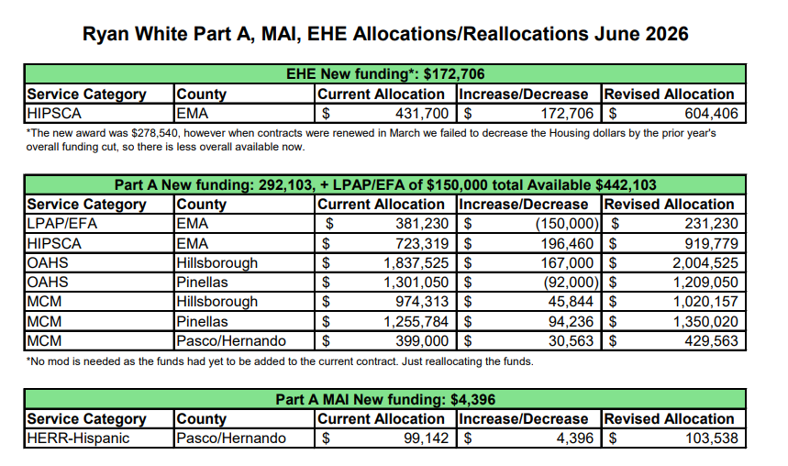  Members voted via roll call vote to approve the Part A Allocations and Reallocations (M: Finn, S: McCoy) (13 yes, 0 no, 0 abstain).  The next RPARC meeting will be on July 9, 2026 at EPIC in St. Pete.  C. Membership and Community Outreach – Anne Cronyn, Committee Chair  Anne Cronyn reported that the Membership and Community Outreach Committee held an election the previous month and Anne was elected chair and Reva Iman was elected co-chair. Members discussed attending a patient support group at the Ybor Youth Clinic to work on recruitment among youth.  The next Membership and Community Outreach Committee meeting will be on July 14, 2026 at Lee Davis Community Center.  D. Health Services Advisory Committee – Katie Scussel, Staff  Katie provided the Health Services report, as neither chair or co-chair were able to attend the meeting that day. Health Services met on June 18th at the Children’s Board of Hillsborough County. Katie explained that the previous month, the Care Council voted to add certain over-the-counter items back onto the Ryan White LPAP formulary. Vitamin D3 with calcium and vitamin D3/K2 were added, but there was an oversight and plain vitamin D was not included in the motion.  Background  In June 2026, the Care Council approved the addition of the following over-the-counter items to be added back to the Ryan White Local Pharmacy Assistance Program (LPAP) formulary: vitamin D3 with calcium, vitamin D3/K2, and diabetic supplies, including test strips, lancets, alcohol swabs, and syringes. Due to an oversight, the motion did not contain plain vitamin D. The Health Services Advisory Committee is recommending that the Care Council add vitamin D back to the formulary, along with the vitamins added the previous month.  Action Required  THAT THE CARE COUNCIL APPROVE THE ADDITION OF VITAMIN D TO THE PART A LOCAL PHARMACY ASSISTANCE PROGRAM (LPAP) FORMULARY  Members voted to approve the addition of vitamin D onto the formulary (M: Finn, S: Williams) (13 yes, 0 no, 0 abstain).  Also at the meeting in June, the committee voted to return to an every other month schedule, now that the situation with ADAP has stabilized. The next HSAC meeting will be on August 20, 2026 at the Children’s Board of Hillsborough County.  E. Women, Infants, Children, Youth, and Families (WICY&F) Work Group – Katie Scussel, Staff  WICY&F did not meet in June.The next WICY&F meeting is scheduled for July 23, 2026 on Zoom. Staff will send out an announcement if the meeting is rescheduled.
COMMUNITY INPUT | There was no community input shared.
PREVENTION ACTIVITIES/QUALITY MANAGEMENT | David Cavalleri presented the quarterly performance measures.  David discussed issues affecting CAREWare reporting among several providers and reviewed the resulting impact on performance data. Members reviewed demographic performance measures by county and population.  Nolan Finn noted that several demographic measures in Polk County were approaching those seen in Pinellas County.
PUBLIC POLICY REPORT | Kevin Williams asked if anyone had any information regarding reductions to Part D funding. Aubrey said that he heard the Part D program is expected to receive approximately a 20% reduction in funding but hadn’t wanted to say anything because he didn’t want to risk spreading misinformation. Sheryl Hoolsema confirmed that she had also been told there would be a 20% reduction. Cheri Mitchell explained that USF is currently working on its grant application and that they had not been told anything directly but that the ceiling amount in the Notice of Funding Opportunity (NOFO) had been reduced to a little under $1 million. The application is due in a few weeks.
ANNOUNCEMENTS | J. Carl Devine announced the upcoming “We the People” march on July 3rd in Fort Lauderdale.  The Care Council will not meet in August. Several staff and members will be in Washington, D.C. for the National Ryan White Conference August 4th through August 7th.
ADJOURNMENT | With no further business to come before the Care Council, the meeting was adjourned at 3:06 p.m.
Note: A recording of the meeting is available by request | For further details about this Care Council meeting, please visit thecarecouncil.org to access meeting minutes and handouts.
LIST OF ATTACHMENTS | - Meeting Agenda – July 2026  - Meeting Minutes – June 2026  - 2026-2027 All Committee Workplan  - 2026-2027 Care Council Work Products Schedule  - Background – Part A Allocation and Reallocation Recommendations  - Part A Allocations  - Background – Part A Formulary Update  - System Wide OAHS HAB Performance Measures  - System Wide OAHS HAB Performance Measures Demographics Breakout
WEBSITES CITED | None

Attendance
Care Council Members | Attendance
E.S. Myles (Chair) | In-person
Bernice McCoy (Vice Chair) | In-person
John Acevedo | Virtual
Chase Barrs
Lillie Bruton | Virtual
Anne Cronyn | In-person
J Carl Devine | Virtual
Nolan Finn | In-person
Brenda Gordon
Reva Iman | Virtual
Nicole Kish
Kamaria Laffrey
Jeffrey Lluberes | Virtual
Marylin Merida | Virtual
Antonio Miles | Virtual
Kim Molnar | Virtual
Joseph Strano
Kevin Williams | In-person
Associate Members | Attendance
Chris Gudis | Virtual
Nataliya Johnson | Virtual
Angela Kellogg
Cheri Mitchell | Virtual
Recipient Staff | Attendance
Aubrey Arnold | In-person
Amanda Bruno | Virtual
Dorinda Lynn | Virtual
Lead Agency Staff | Attendance
Nicole Houston | Virtual
Alix Winston
Suncoast Health Council Staff | Attendance
Barbara Martinez
Alexis Rice | In-person
Katie Scussel | In-person
Regular Guests | Attendance
David Cavalleri | Virtual
Guests | Attendance
Dave Cousineau | Virtual
Don Culpepper | In-person
Daniel Furbee | In-person
Tonicia Freeman-Foster | Virtual
Sheryl Hoolsema | Virtual
Mike Neuges | Virtual
Marisol Sanchez | Virtual
Michelle Scavnicky | Virtual
Taylor Solarsky | In-person
Robert Swayzer | Virtual
James Tirado-Rivera | Virtual
Bernard Washington | In-person

ALT= Alternate present EX = Excused

