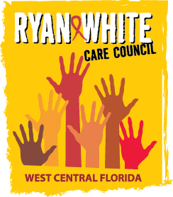
WEST CENTRAL FLORIDA RYAN WHITE CARE COUNCIL
WOMEN, INFANTS, CHILDREN, YOUTH, AND FAMILIES WORKGROUP
ZOOM
THURSDAY, SEPTEMBER 24, 2026
10:00 AM – 11:30 AM

AGENDA

- Call to Order Members

- Roll Call Staff

- Changes to Agenda Members

- Review Minutes Members
July 23, 2026

- Care Council Report Members/Staff

- WIC&F/FAN Collaboration Merida

- Work Plan Members

- Meeting Time, Date, and Location Members

- Women/Youth Concerns/Updates Members

- Community and Client Concerns/Announcements Members/Guests

- Adjournment Members

The Ryan White Care Council next meeting will be on October 7, 2026 from 1:30 pm to 3:30 pm at Lee Davis Community Resource Center.

The next WICY&F Meeting will be on January 28, 2026 at 10:00 am via ZOOM.

The CARE COUNCIL website is operating at www.thecarecouncil.org. Agendas and minutes will be posted on this website.

