HIV/AIDS Needs Assessment Report for the

Tampa- St. Petersburg Eligible Metropolitan Area

2021 - 2022

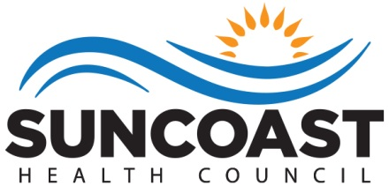

Rob Marlowe, Board Chair

Elizabeth Rugg, Executive Director

Lisa Nugent, Planning Director

Katie Scussel, Ryan White Planning Manager
Who We Are

The health councils were created in 1983 by Florida Statute to identify, address and resolve health care issues of local concern. Each health council is a private, non-profit organization governed by a Board of Directors. The Board members are appointed by County Commissioners to represent the concerns of health care consumers, providers, and purchasers.

The Suncoast Health Council, Inc. (SHC) serves Pasco and Pinellas counties. The Council has extensive experience working with for-profit and non-profit agencies, public health organizations, consumers and professionals. Collaboration and cooperation are critical to the success of our mission.

We have three strategic goals: (1) support the accessibility of health care and social support systems through comprehensive health planning; (2) obtain and provide education about essential community health challenges and solutions; and (3) participate as collaborative partners to develop and sustain efficient and cost effective service delivery systems.

Suncoast Health Council, Inc.

Board of Directors

Rob Marlowe, Chair
Tina Ambrose
Mary Bennett
Dameron Davis
PJ Hamilton
Melissa Johnson
Eric Smith
Nadine Nickeson
Danielle Bierman
Dr. Lawrence Floriani

To Learn More About the Health Council

Visit our website - www.SuncoastHealthCouncil.org

Or Contact Us:

Suncoast Health Council, Inc.

9500 Koger Blvd., Suite 102

St. Petersburg, FL 33702

727-217-7070

727-570-3033 (Fax)
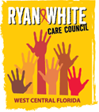

WEST CENTRAL FLORIDA RYAN WHITE CARE COUNCIL

Mission Statement

The mission of the West Central Florida Ryan White Care Council is to manage a high quality, cost-effective, easily accessible, culturally responsive, and comprehensive continuum of care that improves the lives of all individuals living with and impacted by HIV.

Members

E.S. Myles (Chair)
Rachel Brown (Vice Chair)
Steven Becker
Lillie Bruton
Joel Carrier
Anne Cronyn
J. Carl Devine
Nolan Finn
Sheryl Hoolsema
Nataliya Johnson
Riley Johnson
Vincent Kaborycha
Angela Kellogg
Nicole Kish
Kamaria Laffrey
Jeffrey Lluberes
Bernice McCoy
Michelle McKinney
Marylin Merida
Antonio Miles
Dr. Amanda Miller
Kimberly Molnar
Teriko Perkins
Peggy Wallace
Bernard Washington

Produced on behalf of The West Central Florida Ryan White Care Council under contract with the Health Care Services Department within the Human Services of Hillsborough County, Ryan White Program, and the Florida Department of Health in Pinellas County.

This project was supported by the Health Resources and Services Administration (HRSA) of the U.S. Department of Health and Human Services (HHS) as part of an award totaling $10,857,180 with 0 percentage financed with non-governmental sources. The contents are those of the author(s) and do not necessarily represent the official views of, nor an endorsement, by HRSA, HHS or the U.S. Government.

Introduction.................................................................................................................................................1

Epidemiologic Overview............................................................................................................................1

Care Service Strengths and Gaps……………………………………………………….….................……...10

Coordination of Services and Funding Streams....................................................................................17
Planning and Resource Allocation..........................................................................................................18

Service Priorities.......................................................................................................................................19

INTRODUCTION
The Tampa-St. Petersburg Eligible Metropolitan Area (EMA), located on the west central coast of Florida, is comprised of Hernando, Hillsborough, Pasco, and Pinellas Counties. The EMA utilizes Ryan White HIV/AIDS Program (RWHAP) Part A grant funds in support of a comprehensive continuum of high-quality care and treatment for People with HIV in the EMA.

The purpose of this needs assessment is to achieve the goals as defined in the National HIV/AIDS Strategy (NHAS) and to facilitate, support, and execute the mission of the West Central Florida Ryan White Care Council: The mission of the West Central Florida Ryan White Care Council is to manage a high quality, cost-effective, easily accessible, culturally responsive, and comprehensive continuum of care that improves the lives of all individuals living with and impacted by HIV.

EPIDEMIOLOGIC OVERVIEW
Eligible Metropolitan Area Overview:
The Tampa-St. Petersburg Eligible Metropolitan Area (EMA)’s total population is approximately 3.2 million, of which 62% are White (non-Latinx), 21% are Latinx, and 12% are Black (non-Latinx). Women represent 51% of the total population. The geographic layout of the EMA is shown in Figure 1.
Figure 1: The Tampa-St. Petersburg EMA
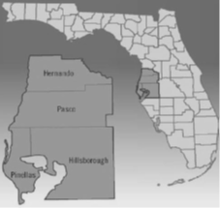

The socioeconomic status of individuals living in the EMA varies throughout the four-county area. Selected characteristics are displayed in Figure 2.

Figure 2: Tampa-St. Petersburg EMA Socioeconomic Profile, 2016-2020
County | Total Population (n) | Median Household Income ($) | Individuals Below the Poverty Level (%) | Residents over 25 w/a high school diploma (%) | Residents over 25 w/a bachelor’s degree or higher (%) | No health insurance coverage (%) | Civilian labor force unemployed (%)
Hillsborough | 1,451,358 | 60,566 | 14.0 | 88.9 | 34.5 | 12.2 | 5.2
Hernando | 190,700 | 50,280 | 14.4 | 88.4 | 19.1 | 12.5 | 6.9
Pasco | 539,885 | 53,431 | 12.3 | 89.9 | 24.6 | 11.5 | 6.0
Pinellas | 970,985 | 56,419 | 11.6 | 91.6 | 32.5 | 10.7 | 5.2
Source: United States Census Bureau, American Community Survey (ACS) 5-year estimates, 2016-2020.
Overview of the HIV Epidemic within the EMA:

According to the Florida Department of Health’s Epidemiological Profile, new HIV cases (incidence) in the EMA decreased 4.4% from 2018 to 2019 and 14.1% from 2019 to 2020, for an overall decrease of 17.9% from 2018 to 2020. New cases of AIDS decreased 12.5% from 2018 to 2020. The decrease in new HIV cases in 2020 should be interpreted with caution, due to the impact of the COVID-19 pandemic on access to HIV testing. Changes in the incidence and prevalence for HIV and AIDS, from 2018 to 2020, are shown in Figure 3.
Figure 3: Tampa-St. Petersburg EMA Epidemiological Profile
 | CY 2018 |  | CY 2019 |  | CY 2020
 | Incidence | Prevalence | Incidence | Prevalence | Incidence | Prevalence
HIV | 563 | 6,603 | 538 | 6,707 | 462 | 6,816
AIDS | 264 | 7,410 | 255 | 7,395 | 231 | 7,414
TOTAL |  | 14,013 |  | 14,102 |  | 14,230
Source: Florida Department of Health, Tampa-St. Petersburg EMA Epidemiological Profiles CY 2018, 2019, 2020. Note: HIV diagnoses cannot be added with AIDS diagnoses to get combined totals, since these categories are not mutually exclusive
Attachment 1 describes the demographic data of People with HIV/AIDS in the EMA, which includes race, age, sex, transmission category, and socioeconomic data.
The most common mode of transmission for individuals diagnosed with HIV/AIDS over the three-year timespan was cisgender male-to-male sexual contact (MMSC), accounting for 988 new cases of HIV and 376 new cases of AIDS between 2018 and 2020. Of these, MMSC among Black cisgender men has resulted in the greatest number of newly diagnosed cases of HIV, followed by MMSC among White and Latinx cisgender men, respectively. Transmission among cisgender heterosexual individuals accounted for 386 new cases of HIV and 249 new cases of AIDS. Black cisgender heterosexual individuals were the most affected among all other races. Persons who inject drugs (PWID) was the third highest mode of transmission with 123 HIV cases and 75 AIDS cases. White persons who inject drugs represented the greatest number of diagnoses among PWIDs of all other races.
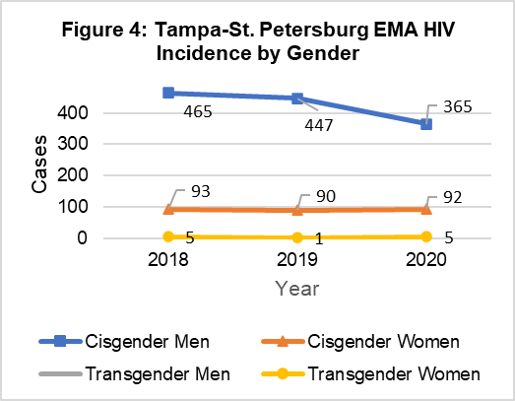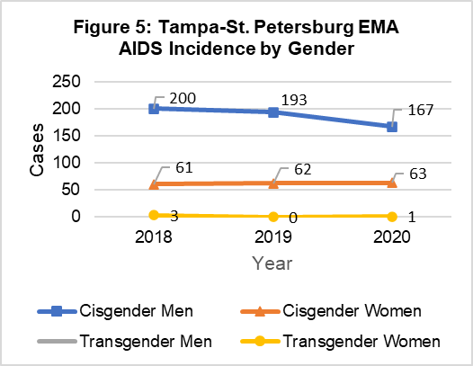
Source: Florida Department of Health, Tampa-St. Petersburg EMA Epidemiological Profiles CY 2018, 2019, 2020.
Figure 4 and Figure 5 show incidence of HIV and AIDS by gender. The incidence of HIV among cisgender men in the EMA decreased from 465 cases in 2018 to 365 cases in 2020: a 21.5% decrease. During the same time frame, new HIV cases among cisgender women remained relatively constant with 93 cases in 2018 and 91 cases in 2020, a 2.2% decrease. The incidence of cisgender male AIDS cases decreased 16.5%, from 200 to 167 cases. The incidence of cisgender female AIDS cases increased 3.3%, from 61 cases to 63 cases.
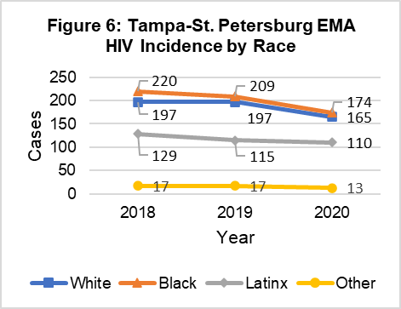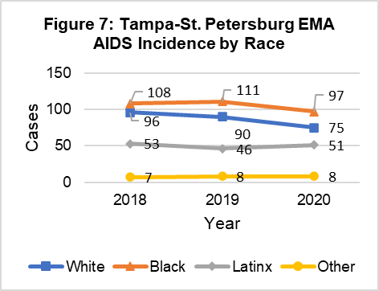
Source: Florida Department of Health, Tampa-St. Petersburg EMA Epidemiological Profiles CY 2018, 2019, 2020.
HIV incidence is shown in Figure 6. Over the past three years, there has been a decrease in HIV incidence in Black, White, and Latinx populations. From 2018-2020, HIV incidence decreased 20.9% among Black persons, 16.2% among White persons, and 14.7% among Latinx persons. The decrease in HIV incidence between 2019 and 2020 should be interpreted with caution, due to the impact of the COVID-19 pandemic on access to HIV testing. The “Other” race category is the combined number of cases among Asian, American Indian/Alaska Native (Indigenous), Native Hawaiian/Pacific Islander, and those who identify as multi-race. This racial category experienced a 23.5% decrease in new HIV cases, from 17 cases in 2018 to 13 cases in 2020.
AIDS incidence is shown in Figure 7. Over the past three years, there has been a decrease in AIDS incidence in White, Black, and Latinx populations, with the most significant decrease in White persons. From 2018-2020, the incidence of AIDS decreased by 21.9% for White persons, 10.2% for Black persons, and 3.8% for Latinx persons. The “Other” race category experienced a 14.3% increase in new AIDS cases; however, contextually this was an increase from seven to eight cases over the three-year period.
The 2020 calendar year saw minor demographic changes in the overall numbers of people with HIV and AIDS (prevalence). White persons in the EMA represented 62% of the population and 43% of all HIV cases. Black persons accounted for 36% and Latinx persons represented 18% of all HIV cases. White persons represented the largest prevalence of AIDS cases in the EMA with 43%, followed by Black persons with 37%, and Latinx persons with 18%. Black persons were disproportionately impacted by HIV/AIDS representing 36% of HIV cases and 37% of AIDS cases, although only 12% of the EMA’s total population was Black. Figure 8 shows HIV and AIDS prevalence by race/ethnicity in 2020, compared to the overall population.
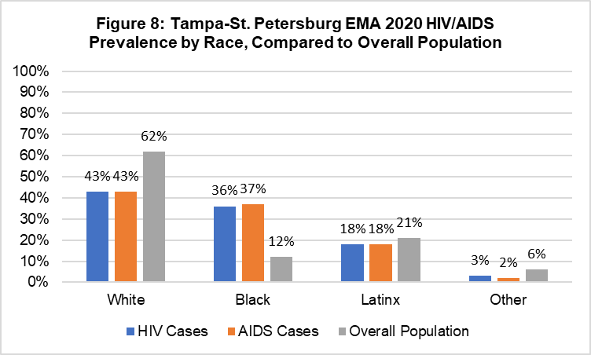
Source: Florida Department of Health, Tampa-St. Petersburg EMA Epidemiological Profiles CY 2018, 2019, 2020.
In the EMA, cisgender men comprise approximately 49% of the population but represent a majority of HIV and AIDS cases. In 2020, cisgender men represented 76.5% of HIV prevalence and 76.2% of AIDS prevalence; cisgender women represented 22.9% of HIV prevalence and 23.3% of AIDS prevalence. Starting in 2020, the Florida Department of Health began providing the EMA with data for transgender women and transgender men; however, it is important to note that due to stigma, many people of transgender experience will not disclose their authentic gender to providers for fear of mistreatment and discrimination. As a result, many transgender women may be incorrectly attributed as men and many transgender men may be categorized as women. Transgender women represent 0.5% of both HIV and AIDS prevalence, and transgender men represent 0.0% of HIV and AIDS prevalence. As the acceptance and affirmation of transgender populations strengthen, it can be expected that these numbers will increase as individuals feel safer disclosing their authentic selves to their providers. Consideration should also be made for the absence of a third transgender identification option. There are many transgender individuals who do not identify as a binary gender, but rather as a gender that is included within the non-binary umbrella. Figure 9 shows HIV and AIDS prevalence by gender in 2020.
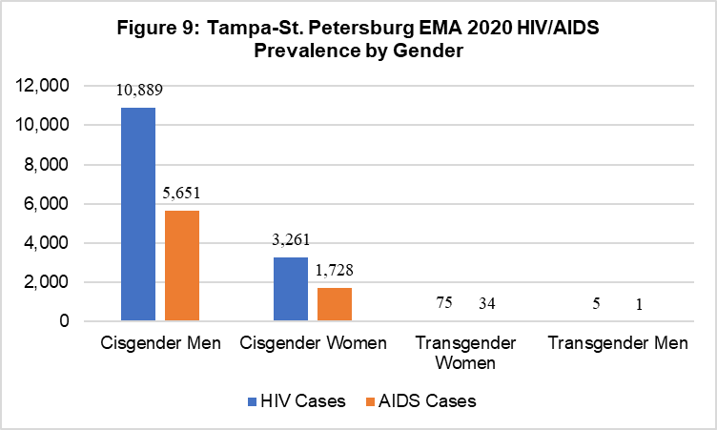
Source: Florida Department of Health, Tampa-St. Petersburg EMA Epidemiological Profiles CY 2018, 2019, 2020.
Over the past three years, there have been minimal increases and decreases in HIV/AIDS prevalence among all races. Latinx persons in the EMA saw the greatest increase (4.1%) in HIV/AIDS prevalence from 2,485 cases in 2018 to 2,587 cases in 2020, followed by Black persons (1.8%) HIV/AIDS prevalence from 5,091 to 5,182 cases over the same three-year period. White persons in the EMA experienced a marginal increase in HIV/AIDS prevalence (0.05%) from 6,087 cases in 2018 to 6,090 cases in 2020. Prevalence of HIV/AIDS among “Other” races, combined, increased (6%) from 350 cases to 371 cases. Within the “Other” racial category, the most significant change was in Asian persons who saw an increase (11.7%) of cases from 128 in 2018 to 143 in 2020. When stratified, changes in HIV/AIDS prevalence among the other individual races within this category were negligible.
In 2020, there were 5,182 Black people with HIV/AIDS in the EMA. Approximately 16% of people with HIV/AIDS in this racial group were aware of their status and not in care. There were 2,587 Latinx people with HIV/AIDS in the EMA in 2020 and approximately 18% were aware of their HIV/AIDS status and not in care. There were 6,090 White people with HIV/AIDS in the EMA in 2020. Approximately 12% of people with HIV/AIDS in this racial group were aware of their status and not in care. When compared to the continuum of care in 2018, there has been an increase in linking and engaging People with HIV to care, among all races in the EMA. Additional care continuum data from this time period is available in the 2021 HIV/AIDS Care Continuum Report for the Tampa-St. Petersburg Eligible Metropolitan Area.
Figure 10 shows the total number of People with HIV/AIDS in the EMA in 2020 by county.

Figure 10: Tampa-St. Petersburg EMA HIV/AIDS Cases per County in 2020
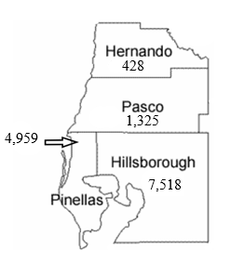

New and Emerging Populations:
The Florida Department of Health’s 2020 Epidemiological Profile reports that while new HIV cases in cisgender male youth (13-24) decreased overall from 2018-2020 across all races, White and Black cisgender male youth saw an increase from 2018-2019. Cases in White cisgender male youth increased 11.8% from 2018-2019 and decreased 57.9% from 2019-2020 while cases in Black cisgender male youth increased 19.5% from 2018-2019 and decreased 36.7% from 2019-2020. It is likely that the numbers of new HIV diagnoses in these populations in 2020 are artificially low due to the impacts of the COVID-19 pandemic on HIV testing activities. From 2018-2020, cases decreased 39.1% in Latinx cisgender male youth and 25% in Black cisgender female youth. While White and Latinx cisgender female youth have low numbers of cases overall, there were very slight increases in both populations. White cisgender female youth increased from three cases in 2018 to five cases in 2020 and Latinx cisgender female youth increased from one case in 2018 to two cases in 2020.
Unique challenges for youth include social, economic, and cultural barriers that limit access to prevention and care. Stigma and misinformation about HIV contribute heavily to the disproportionality high rates of HIV among youth. Low rates of condom use, substance misuse, and partner age differences (and the potential for coercion in these relationships) are prevention challenges for this emerging population. Youth are more likely to forego needed health care due to lack of access to transportation, lack of time off from work and school, fear, lack of insurance, disapproval from family and peers, and not feeling sick. Service delivery for this emerging population is coordinated through partnerships among EMA community providers, Recipient-funded services, Part B and D funds, as well as Medicaid.
The Florida Department of Health’s 2020 Epidemiological Profile reports 21% (n=3,016) of People with HIV in the EMA who were aware of their status were not retained in medical care. Populations in the EMA that are Ryan White eligible and under-represented in care include: Black cisgender female youth (13-24), Latinx cisgender male persons who inject drugs (PWID), White cisgender Women of Childbearing Age (WCBA), White cisgender male PWID, and Black cisgender male PWID. Respectively, 29.7% (n=11) of Black cisgender female youth, 29.3% (n=55) of Latinx cisgender male PWID, 29% (n=69) of White cisgender WCBA, 28.9% (n=57) of White cisgender male PWID, and 28% (n=67) of Black cisgender male PWID were not retained in medical care in 2020.
Additionally, Black and Latinx populations were chosen as the Minority AIDS Initiative (MAI) populations of focus due to their under-representation in the Ryan White system of care and their lower-than-expected number of People with HIV retained in medical care. In 2020, 23.4% (n=1,211) of Black People with HIV and 23% (n=595) of Latinx People with HIV in the EMA were not retained in medical care. In contrast, in 2018, 26.4% (n=1,346) of Black People with HIV and 24.9% (n=619) Latinx People with HIV in the EMA were not retained in medical care. This significant increase in retention in medical care, for both populations, indicates that the EMA has improved linkage to care in the span of two years, despite ongoing barriers to access to care caused by the COVID-19 pandemic.
HIV/AIDS Cases within the Total Service Area (TSA)
The State of Florida is comprised of numbered areas. The West Central Florida Ryan White Care Council covers three areas: Area 5, Area 6, and Area 14. To provide information regarding all the areas covered by the Care Council and not just the EMA, Figures 11 – 17 represent the three geographic areas that make up the Total Service Area (TSA).
Figure 11 shows the number of People with HIV (PWH) per 100,000 population for all eight TSA counties.
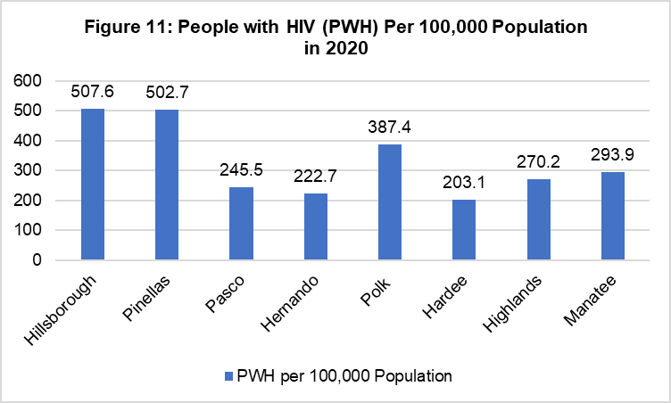

Figures 12-17 show new cases (incidence) of HIV and AIDS in each area, broken down by county of residence at diagnosis.

AREA 5: PASCO & PINELLAS COUNTIES

Figure 12: HIV by Year of Diagnosis in Area 5
by County of Residence at Diagnosis, 2018-2020

County  HIV Incidence | 2018 | 2019 | 2020 | 2018-2020  % Change
Pasco | 52 | 49 | 40 | -23.1%
Pinellas | 179 | 193 | 159 | -11.2%

Source: Florida Department of Health, HIV/AIDS Section, 2020

Figure 13: AIDS by Year of Diagnosis in Area 5
by County of Residence at Diagnosis, 2018-2020

County  AIDS Incidence | 2018 | 2019 | 2020 | 2018-2020  % Change
Pasco | 22 | 21 | 20 | -9.1%
Pinellas | 85 | 89 | 80 | -5.9%

Source: Florida Department of Health, HIV/AIDS Section, 2020

AREA 6: HERNANDO, HILLSBOROUGH, & MANATEE COUNTIES

Figure 14: HIV by Year of Diagnosis in Area 6
by County of Residence at Diagnosis, 2018-2020

County  HIV Incidence | 2018 | 2019 | 2020 | 2018-2020  % Change
Hernando | 17 | 10 | 11 | -35.3%
Hillsborough | 315 | 286 | 252 | -20.0%
Manatee | 44 | 35 | 40 | -9.1%

Source: Florida Department of Health, HIV/AIDS Section, 2020

Figure 15: AIDS by Year of Diagnosis in Area 6
by County of Residence at Diagnosis, 2018-2020

County  AIDS Incidence | 2018 | 2019 | 2020 | 2018-2020  % Change
Hernando | 13 | 5 | 6 | -53.8%
Hillsborough | 144 | 140 | 125 | -13.2%
Manatee | 21 | 17 | 29 | 38.1

Source: Florida Department of Health, HIV/AIDS Section, 2020

AREA 14: HARDEE, HIGHLANDS, & POLK COUNTIES

Figure 16: HIV by Year of Diagnosis in Area 14
by County of Residence at Diagnosis, 2018-2020

County  HIV Incidence | 2018 | 2019 | 2020 | 2018-2020  % Change
Hardee | 2 | 0 | 0 | -100%
Highlands | 6 | 13 | 10 | 66.7%
Polk | 108 | 130 | 78 | -27.8%

Source: Florida Department of Health, HIV/AIDS Section, 2020

Figure 17: AIDS by Year of Diagnosis in Area 14
by County of Residence at Diagnosis, 2018-2020

County  AIDS Incidence | 2018 | 2019 | 2020 | 2018-2020  % Change
Hardee | 2 | 1 | 1 | -50.0%
Highlands | 4 | 8 | 5 | 25.0%
Polk | 45 | 56 | 40 | -11.1%

Source: Florida Department of Health, HIV/AIDS Section, 2020

CARE SERVICE STRENGTHS AND GAPS
The EMA has a strong history of collaboration between all patient care and prevention funded programs and actively promotes cross-collaboration. In addition to the Care Council, the Ending the HIV Epidemic (EHE) grants also have planning groups that meet monthly which include the two CDC funded grants for Hillsborough and Pinellas County as well as the HRSA funded EHE grant which covers both jurisdictions. Each grant has a separate planning group. Due to the recent expansion in the number of planning groups, the EMA needs to consider consolidation of the local patient care and prevention planning to achieve a higher level of community involvement as there tend to be competing interests for time, especially with community volunteers who have interest but may be limited on their time due to work or other obligations.

Cultural and language barriers in the EMA may hinder access to care, due to the cultural and linguistic diversity of the area. To increase access to care, all Ryan White direct services are delivered by providers who employ bilingual staff, provide language interpretation services, and who strive to provide culturally sensitive care. Agencies prioritize hiring employees who culturally reflect the HIV population that they serve. In addition to Spanish speaking staff, some agencies within the EMA have staff who speak Haitian Creole. To ensure that services are as accessible as possible, the Recipient evaluates accessibility standards during the application process for each provider to ensure quality of care and services. In addition to having bilingual staff, providers are expected to have locations along bus routes and offer after-hours appointments. Florida (and the local EMA) has an inconsistent patchwork of health care options, depending on what area of the state one resides in. Urban areas with locally funded programs generally offer more choice and access compared to rural areas.

The Kaiser Family Foundation reports (January 2021) that if Florida had not rejected federal dollars for Medicaid expansion, an estimated 833,000 more residents would have health insurance because all who earn up to 138% of the Federal Poverty Level would be covered. Floridians in the Medicaid gap are adults who earn too little to qualify for Affordable Care Act (ACA) subsidies and are ineligible for Medicaid unless they fall into a special category, such as pregnant people, parents of children under 19, seniors, and people with certain disabilities.

According to statistics from Medicaid.Gov and the Kaiser Family Foundation, Florida Medicaid covers 3.6 million low-income children, pregnant people, adults, seniors, and people with disabilities. Based on Florida’s population of approximately 21.4 million people in 2020, 19% of the population are covered by some form of Medicaid or the State Children’s Health Insurance Program (SCHIP), and 31% of the population is defined as low income, which is anyone living below 200% of the Federal Poverty Level. The latest efforts to expand Medicaid in Florida involve a ballot initiative going to voters in late 2022.

In addition to these options, the EMA has two locally funded health care plans for low-income residents: the Hillsborough Health Care Plan (HCHCP) and the Pinellas County Health Plan (PCHP) that offer primary care and other core medical services to qualifying residents. The HCHCP is more robust in the fact that it covers individuals without other health options up to 175% of the Federal Poverty Level (FPL). The PCHP covers individuals up to 100% of the FPL. Both require documentation of county residency, proof of income, identification, etc. for eligibility purposes. Eligible clients are then enrolled and are assigned to a clinic medical home for primary care, which focuses on prevention and management of chronic diseases. The HCHCP offers limited dental services as well as other ancillary services, including three wellness centers which offer HCHCP members access to nutrition counseling, and fully equipped fitness centers with staff who can provide a customized fitness plan based on individual needs and personal training, as well as fitness classes.

Services in Pasco and Hernando counties, which are less densely populated, are not as accessible due to there being less provider locations and very limited public transportation. Stigma is still a significant barrier, especially for People with HIV who reside in less densely populated areas, as they tend to be more isolated and may fear disclosing their HIV status to family or friends. It is still routine for service providers in more densely populated areas to serve clients who will travel from their less densely populated communities for care rather than risk being seen by people they know or disclosing their HIV status to the local health department provider, who may be the sole HIV service provider in their county of residence.
Mental health and pain management services are severely limited and therefore difficult to access in the EMA. The opioid epidemic has contributed to additional controls and restrictions, which took effect with Florida legislation on July 1, 2018. Specialty care services were traditionally enhanced and/or supplemented by state general revenue funds and in-kind contributions since the pool of specialists who accept the cost-based reimbursement price is limited, especially in the less densely populated areas. Most specialist care is provided in the more densely populated areas/large cities necessitating travel over long distances for many where transportation is already a barrier. Coordination of all these services and the significant wait times for specialist appointments can be frustrating for clients and may cause them to fall out of care or not seek the specialist care needed.
Long Acting Injectables (LAI’s) have been successfully added to the local HIV continuum of care in 2021, with the Florida Department of Health AIDS Drug Assistance Program (ADAP) paying for the cost of the medications and Ryan White Part A covering the cost of the office visit. We have not seen a surge in utilization yet, but LAI’s are available throughout the EMA for any patient who meets the medical protocol.
Due to the Florida Legislature opting not to accept the Medicaid expansion funding made available by the Affordable Care Act (ACA), the EMA has continued to focus Ryan White patient care funds only on provision of core services. The Care Council, in the prioritization and allocation process, reviews all service categories, including those which are not funded, and considers other funding streams. The Care Council considers these categories, in the event additional funds are made available or utilization trends change for core services due to the impact of the ACA or other initiatives.
Expanding access to oral health remains a priority but is a difficult challenge due to level Ryan White Part A funding and a lack of dental providers. Utilization dropped during the height of the COVID-19 pandemic but despite some patient hesitancy is now increasing again. Access to Substance Misuse and Mental Health services is another area of focus since Substance Misuse services are not available in the two outlying counties and the allocation for Mental Health services is very minimal in those same areas. During the pandemic these two services increased utilization significantly using telehealth and smart phone technology which allowed those patients that had access to a mobile device the opportunity to continue to receive counseling services (both individual and group). This had a positive impact on patients who were vulnerable and living in isolation.
Utilizing e2Hillsborough, the EMA has been able to rapidly identify new HIV clusters. The Part A Recipient’s Office will collaborate with community partners and provide input on county-wide media/marketing campaigns that focus on prevention, youth education and training services, and stigma reduction.
The AIDS Institute, which serves as the coordinating entity for the EHE HRSA cooperative agreement, is also involved in two statewide Molecular Surveillance (HIV Transmission Networks) initiatives. These initiatives include focus groups, community surveys, and webinars aimed to address community concerns and help reduce stigma. Information and lessons learned will be utilized to help inform community education efforts.
Florida is particularly vulnerable to hurricanes and other weather events which can seriously disrupt an already fragile service delivery system. As a result of COVID-19, state and local officials need to consider social distancing measures and the impact on shelter space and how to provide transportation to shelters that limit the risk of exposure. A shortage of space may leave low-income populations with very few options if large scale evacuations are needed.
The Tampa-St. Petersburg EMA was directly impacted in 2017 by Hurricane Irma. Over 230,868 customers were left without power, approximately 36% of the county. Heavy rainfall resulted in flooding along the Alafia, Hillsborough, and Little Manatee Rivers. Forty-one businesses and homes were demolished, and 130 suffered extensive damage. Hurricane Irma cost the county almost $20 million in damages, with an additional loss of $28.5 million in citrus plants.
On September 28, 2022, Hurricane Ian hit southwest Florida and traveled through the EMA impacting residents and services. Many residents lost power and experienced damages due to wind and flooding. Many businesses closed in preparation for the storm and remained closed for several days to a week or more. A hurricane may last a day or two but the impact that it leaves on the community are detrimental to many of the systems needed to support a person’s ability to access the things that keep them healthy. For example, a person may not be able to go to work, access their medications or attend medical appointments. The environmental challenges the EMA is faced with increases the burden associated with the social determinants of health.
The EMA identified service gaps as a component of the most recent 2019 HIV Care Needs Survey, which was completed across the Total Service Area (TSA) of the West Central Florida Ryan White Care Council to ensure diversity and representativeness in the sample. The TSA is comprised of the EMA with the addition of Polk, Manatee, Highlands, and Hardee counties. The 2019 HIV Care Needs Survey was distributed on paper to a total of 30 sites, selected by Care Council Support staff. The sites consisted of primary care providers (public and private), HIV/AIDS case management agencies, and other AIDS service organizations (ASOs). A survey link was distributed through the Care Council e-mail listserv and posted on the Care Council’s website. The survey link was posted on the Care Council’s Facebook page and on the Facebook pages of other providers as well. A postage-paid return envelope was provided with all surveys at sites without a collection box. The EMA also received support from other integral organizations with a wide reach in the community, such as St. Petersburg, Pasco, and Tampa Pride organizations. Key staff at several of the survey sites collaborated in the distribution by asking clients to complete the survey and helped with completing the survey as needed. The EMA had a total of 618 surveys returned, representing a statistically valid sampling rate which is >10% of our unduplicated population being served. With the use of online data collection software, all surveys were examined for each individual question answered and preliminary analysis of the data was distributed to all areas.
Figure 18 showcases the service gaps for People with HIV in the EMA as identified in the 2019 HIV Care Needs Survey. The services are ranked in order from highest service gap percentage to lowest service gap percentage.
Figure 18: 2019 HIV Care Needs Survey Service Gaps
Service | Service Gap Percentage (%) |  | Total %  (% is rounded)
 | Needed service, but could not get service | Needed service, but did not know about service
Dental/Oral Health | 11.1% | 9.2% | 20%
Food Bank of Food Vouchers | 3.5% | 11.5% | 15%
Legal Support | 4.2% | 8.8% | 13%
Mental Health Services | 4.7% | 7.0% | 12%
Housing | 5.4% | 5.7% | 11%
Health Insurance | 6.1% | 3.4% | 10%
Transportation | 4.0% | 6.1% | 10%
Outreach | 2.7% | 6.7% | 9%
Peer Mentoring | 3.9% | 3.9% | 8%
Home Health Care | 2.7% | 4.1% | 7%
Medical Case Management | 3.1% | 2.8% | 6%
Health Education / Risk Reduction | 2.1% | 3.2% | 5%
Substance Misuse Treatment | 2.5% | 1.7% | 4%
Hospice Services | 1.2% | 2.5% | 4%
Treatment Adherence | 2.8% | 1.2% | 4%
Outpatient Ambulatory Health Services | 1.5% | 1.0% | 3%
Medications | 2.1% | 1.0% | 3%
Source: Florida Department of Health Statewide HIV Care Needs Survey, 2019.

Figure 19 showcases the prioritized services for People with HIV in the EMA as identified in the 2019 HIV Care Needs Survey. Ryan White services are ranked in order from highest service priority to lowest service priority.

Figure 19: 2019 HIV Care Needs Survey Service Priorities
Service | % of Survey Responses
Medications | 80%
Health Insurance | 62%
Medical Case Management | 60%
Dental/Oral Health | 57%
Outpatient Ambulatory Health Services | 45%
Housing | 34%
Mental Health | 33%
Food Bank or Food Vouchers | 21%
Emergency Financial Assistance | 21%
Health Education / Risk Reduction | 11%
Substance Misuse Treatment | 10%
Nutritional Counseling | 9%
Legal Services | 8%
Peer Support | 7%
Home Health Care | 7%
Outreach | 7%
Referral for Health Care | 7%
Early Intervention Services | 6%
Hospice Services | 4%
Substance Misuse Residential Treatment | 4%
Child Care | 3%
Rehabilitation Services | 3%
Linguistic Services | 2%
Source: Florida Department of Health Statewide HIV Care Needs Survey, 2019.

HIV care services that are not currently funded by Ryan White were assessed in the 2021 Ryan White Services Needs Assessment Survey. The following services were identified to be among the top priorities among non-funded service categories: short-term emergency housing assistance; transportation to HIV-related appointments; food and/or nutritional supplement assistance; and legal services for HIV-related issues (wills, living wills, social security, and disability).
The Care Council prioritizes and allocates funding based on a grid which divides core and non-core (support) services. The EMA has focused on allocating funds to core services for the past several years, primarily due to the unmet need which continues to exist in core services, such as substance abuse, health insurance, mental health, oral health, and medical case management. Due to the Florida Legislature opting not to accept the Medicaid expansion funding made available by the Affordable Care Act (ACA), the EMA is unable to fund all the above service gaps identified since the area continues to focus attention on core services. All but three of the top ten ranked service gaps (oral health, mental health, and health insurance) in Figure 17 are defined as non-core services. The Care Council, in the prioritization and allocation process, reviews all service categories, including those which are not funded, and considers other funding streams. The Care Council considers these categories, in the event additional funds are made available or utilization trends change for core services due to the impact of the ACA.

The 2022 HIV Care Needs survey will be deployed in October 2022 and results will be reviewed by the Care Council before establishing the 2023-2024 service priorities.

COORDINATION OF SERVICES AND FUNDING STREAMS

Attachment 2 presents the funding available in the EMA. The table was developed with input and information from the Area 5, 6, and 14 HIV Planning Partnership (the local HIV prevention planning body), the Care Council, the Ryan White Part A, B, and D Recipients, and the Florida Department of Health. The table includes each Part of Ryan White HIV/AIDS Program funding and other known federal, state, and local funding streams. This information is from the EMA’s Integrated Plan, adopted by the Care Council in October 2022.

Due to the diverse nature of the Tampa-St. Petersburg EMA (two of the counties are urban and two semi-rural), the Care Council and Recipient recognized that parity must be a primary consideration when allocating funds within the four-county area. All the counties have basic services provided, including outpatient ambulatory health services, AIDS pharmaceutical assistance (local), emergency financial assistance, medical case management, oral health, mental health, substance abuse-outpatient, and health insurance premium and cost-sharing assistance. In October 2022, the Care Council voted to allocate additional funding for mental health and substance abuse services in Pasco and Hernando counties, in order to increase parity across the four-county area. The Care Council also voted to allocate funding for a housing program in these two counties, as Pinellas and Hillsborough counties have housing funded under Ending the HIV Epidemic (EHE) grants.

There are five core services that are not funded with Ryan White Part A HIV/AIDS Program funds, including medical nutrition therapy, early intervention services, home health, hospice services, and home/community-based health services. These services are all prioritized by the Care Council, with no allocations because all the services have other payer sources. Due to the unmet need in the top priority categories such as outpatient ambulatory health services, the Care Council cannot, with limited funding, expand beyond the top eight funding priorities. It has not funded other supportive services such as legal assistance, food banks, and housing for many years.

The EMA, including the Care Council and the Recipient, reviews the annual Women, Infants, Children, and Youth (WICY) expenditure data to ensure that resource allocations to provide services to these subpopulations are consistent and in proportion to the percentages of the EMA’s reported AIDS cases. Three Ryan White Parts are represented in the EMA: Parts A, B, and D, and all of them fund services for the WICY populations. Part A and Part B funds are planned concurrently through the Care Council to ensure appropriate allocations, with Part D being represented on the Care Council and with a well-established linkage and coordination of services.

The area does not currently receive Ryan White Part C or Part F funds. The EMA does have providers who are funded to provide HIV/AIDS prevention and treatment by the Centers for Disease Control and Prevention (CDC) and the Substance Abuse and Mental Health Services Administration (SAMHSA). The area also has a Housing Opportunities for Persons with AIDS (HOPWA) program that provides housing services. Two counties in the EMA (Hillsborough and Pinellas) receive direct Ending the HIV Epidemic funding. The State of Florida and Hillsborough County Government also contribute to the EMA’s funding streams for HIV prevention and care.

In FY 2021, the EMA received Coronavirus Aid, Relief, and Economic Security (CARES) Act funding in the amount of $740,849. These funds were allocated to help Ryan White recipients respond to the COVID-19 pandemic.

PLANNING AND RESOURCE ALLOCATION

The EMA holds community input as a core component of providing Ryan White services. The main sources of community input are needs assessment surveys, the Integrated Plan, the Care Council, and, historically, the Care Council’s committees. The Care Council committees include: Planning and Evaluation; Membership, Nominations, Recruitment and Training Committee; Standards, Issues and Operations (SIOC); Resource Prioritization and Allocation Recommendations (RPARC); Women, Infant, Children, Youth and Families (WICY&F); Health Services Advisory; and the Community Advisory Committee. Due to difficulty meeting quorum during the COVID-19 pandemic, the Care Council suspended all committees except for WICY&F from a period of October 2021 through December 2022. During this same period, the Care Council held a series of virtual town hall meetings for members and the local community to discuss any issues within the Care Council or the HIV service delivery system. Planning activities are influenced by the updated National HIV/AIDS Strategy and the HIV Care Continuum. The Care Continuum is used by the Care Council to analyze gaps in service and determine how to best allocate Part A funding. The planning process highlights the need to fund categories, such as medical case management, that help navigate clients in the EMA along the HIV Care Continuum.

Epidemiological data is updated and reviewed annually as part of the needs assessment process. Changes in the data as well as trends are considered by the Care Council when setting priorities. Due to the increases and disproportionate impact among the historically underserved populations of Latinx and Black persons in the EMA, targeted efforts within the Minority AIDS Initiative (MAI) Projects were developed. HIV incidence increased 34% among Latinx persons from calendar year 2019 to calendar year 2021 but decreased 11% among Black persons over the same time span. From calendar year 2019 to calendar year 2021, the incidence of AIDS increased by 30% in Latinx persons and decreased by less than 1% in Black persons. The EMA’s MAI continues to fund the Health Education and Risk Reduction (HERR) service category to continue to address barriers to care and improve retention within the Ryan White systems of care.

To allocate resources, the Care Council considers service utilization, expenditures, and allocations to each service category across public funding streams and estimates of unmet need. The Council then discusses the implications of the service rankings and finalizes the priority rankings before adoption. Funding is allocated according to the service priorities, with consideration for other available funding sources for support services within the community. Due to a decrease in utilization in AIDS pharmaceutical assistance and emergency financial assistance in fiscal year 2021-2022, the Care Council was able to allocate additional funding to outpatient ambulatory health services, medical case management, mental health, and oral health.

SERVICE PRIORITIES
The Care Council sets service priorities based on information from the 2019 HIV Care Needs Survey. The FY 2022-2023 Service Priorities are listed in Figure 20.
Figure 20: Service Priorities

- Outpatient/Ambulatory Health Services  - AIDS Pharmaceutical Assistance (local)  - Emergency Financial Assistance*  - Medical Case Management  - Oral Health (dental) Care  - Health Insurance Premium and Cost Sharing Assistance  - Mental Health Services  - Substance Abuse Services - outpatient  - Health Education/Risk Reduction  - Case Management (non-medical)  - Housing Services  - Treatment Adherence Counseling  - Early Intervention Services  - Medical Transportation Services  - Legal Services  - Outreach Services | - Child Care Services  - Food Bank/Home Delivered Meals  - Medical Nutrition Therapy  - Psychosocial Support Services  - Substance Abuse Services- residential  - Home Health Care  - Home and Community Based Health Services  - Rehabilitation Services  - Linguistic Services (interpretation & translation)  - Hospice Services  - Respite Care  - Referral Services
*The Emergency Financial Assistance (EFA) category will cover ADAP medications only, for those eligible clients who have been approved for ADAP and are still in the waiting period, which will serve as a “bridge” program in the manner it has historically.

EMA AIDS Prevalence and HIV* Prevalence Data by Demographic Group and Exposure Category
Attachment 1

Demographic Group/  Exposure Category | 2018-PREVALENCE |  | 2019-PREVALENCE |  | 2020-PREVALENCE
Race/Ethnicity | HIV | AIDS | HIV | AIDS | HIV | AIDS
White, not Latinx | 2,791 | 3,296 | 2,813 | 3,239 | 2,869 | 3,221
Black, not Latinx | 2,424 | 2,667 | 2,461 | 2,688 | 2,476 | 2,706
Latinx | 1,219 | 1,266 | 1,251 | 1,285 | 1,291 | 1,296
Other / Unknown | 169 | 181 | 182 | 183 | 180 | 191
Total | 6,603 | 7,410 | 6,707 | 7,395 | 6,816 | 7,414
Gender | HIV | AIDS | HIV | AIDS | HIV | AIDS
Cisgender Men | 5,042 | 5,634 | 5,155 | 5,630 | 5,238 | 5,651
Cisgender Women | 1,517 | 1,736 | 1,511 | 1,730 | 1,533 | 1,728
Transgender Women | 39 | 38 | 37 | 34 | 41 | 34
Transgender Men | 5 | 2 | 4 | 1 | 4 | 1
Total | 6,603 | 7,410 | 6,707 | 7,395 | 6,816 | 7,414
Current Age as of Reporting Year | HIV | AIDS | HIV | AIDS | HIV | AIDS
<13 years | 12 | 3 | 8 | 3 | 9 | 2
13 - 24 years | 338 | 78 | 309 | 56 | 275 | 47
25 - 44 years | 2,873 | 1,672 | 2,944 | 1,656 | 2,977 | 1,609
45 - 59 years | 2,373 | 3,819 | 2,336 | 3,661 | 2,327 | 3,522
60+ years | 1,007 | 1,838 | 1,110 | 2,019 | 1,228 | 2,234
Total | 6,603 | 7,410 | 6,707 | 7,395 | 6,816 | 7,414
Exposure Category | HIV | AIDS | HIV | AIDS | HIV | AIDS
Cisgender Male-to-male sexual contact (MMSC) | 4,064 | 3,919 | 4,156 | 3,944 | 4,230 | 3,969
Injection drug users (IDU) | 423 | 735 | 429 | 703 | 439 | 697
MMSC/IDU | 290 | 439 | 286 | 442 | 280 | 421
Cisgender Heterosexual Contact | 1,708 | 2,159 | 1,726 | 2,158 | 1,756 | 2,176
Transgender Sexual Contact | 39 | 32 | 35 | 30 | 38 | 30
Perinatal Exposure | 12 | 3 | 8 | 3 | 9 | 2
Other/Unknown | 65 | 123 | 66 | 116 | 63 | 119
Total | 6,601** | 7,410** | 6,706** | 7,396** | 6,815** | 7,414**
Source: Florida Department of Health EMA Epidemiological Profiles CY 2018; CY 2019; CY 2020 as of August 11, 2021

*People without an AIDS diagnosis, solely HIV prevalence

**Risk data are calculated values from a weighted database to redistribute the NIRs into known vulnerabilities. Therefore, some vulnerability data was off from the total due to rounding issues, according to the Florida Department of Health.

Attachment 2

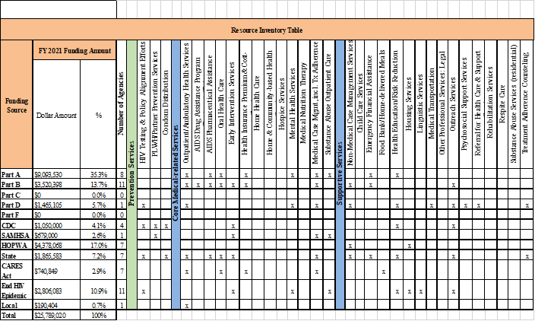

Cisgender is the gender descriptor used for all men and women whose current gender aligns with their sex assigned at birth
Non-binary is an umbrella term for all gender identities and expressions outside the gender binary; often referred to as enby
Includes IDU of ALL genders, excluding MMSC/IDU
Includes specifically cisgender male and cisgender female heterosexual contact. Cisgender is defined as men and women who identify with the gender they were assigned at birth (not of transgender experience)
“Transgender Sexual Contact” is specific to all persons of transgender experience and is an aggregate of all sexual contact among all transgender populations, as categorized and reported by the Florida Department of Health

